 PRAGATI PUBLIC SCHOOL
HOLIDAY HOMEWORK
CLASS –X
AY-2018-19

Dear Children
At last the much awaited summer holidays have begun. Summer vacation full of fun, frolic and relaxation will make you happy and regenerated. Most of you must be excited about the travel plans your parents have made for you during the vacation. And no doubt, the sweltering heat of June, the 45o C and above temperatures, will surely keep you busy and occupied.
We have some very useful Holiday Homework for you this vacation. We are sure you will like to take some time off your leisure time during these holidays so that when you join back, you are not short of your practice and rhythm. It is very important as 10th students will be facing board exam in current session with full syllabus. You are sure to enjoy these . The homework have been chosen with a lot of deliberation. Utmost care has been taken to ensure that you use your creativity, your innovative ideas and your imagination to shape your projects into beautiful, wonderful ‘creations’.
All the Best and Have Fun!!

English
Julius Caesar-Question Bank

- Whom do you consider as the hero of the play Julius Caesar? Give reasons for your answer.

- Discuss Julius Caesar as a tragedy of internal conflict.

- Justify the title of the play Julius Caesar.

- Discuss Shakespeare’s use of the supernatural in his tragedy Julius Caesar.

- Enumerate Shakespeare’s use of the omens, portents and other superstitions in the drama. Comment on whether they are to be distinguished from the supernatural in the play.

- Give an account of Shakespeare’s representation of the mob.

- “Cassius is able to initiate Brutus but fails to regulate him”. Discuss.

- Cassius and Brutus have the same goal but different intentions. Draw a contrast in their approach and attitude.

- The women in Julius Caesar play a secondary role. Comment.

- Show how is the murder of Caesar by Brutus was not only a crime but also a political blunder.

- “Julius Caesar is more of a tragedy than a historical play” Comment.

- Discuss friendship in the play. (Consider Caesar and Brutus, Caesar and Antony, Brutus and Cassius, Antony and Octavius.)

- Julius Caesar is a play about statehood and leadership. Justify.

- Critics claim that Caesar is not a black and white character but is depicted in shades of grey. Comment.

WRITING SKILL & GRAMMAR
Question 15.(a) You are Sonal/ Samkit of Vidyanjali Public School , Lucknow. You have seen an advertisement in ‘The Times of India ’ related to new batches of ‘Astronomy Club’initiated by National Science Centre , Lucknow starting from the coming fortnight .You wish to join the Club. Write a letter to the Director, enquiring about the venue, duration, fee-structure, activities, transportation etc. Invent other necessary details (100-120 words, 8 Marks)
OR
(b) You are the In-charge of the Medical Section of Gyanodaya Public School, Nehru Vihar, Alwar. Your stock of medicines is about to finish. Write a letter to the Director of Jambo Medicare, Delhi, ordering medical items like glucose, crocin, bandages, tincture, pain-healers, ointments etc. Ask for discount on bulk order .Invent other necessary details. (100-120 words , 8 Marks)
Question 16. Write a short story, in about 200-250 words, with any one set of the cues given in the boxes below. Give a suitable title to the story. (10marks)
Jasmine , Ali and two other friends decided to go on a picnic to a beach. They packed their bags and were quite excited. They reached the picnic spot and came across a small child who was crying ………..
OR
On October 4 ,we all were decorating our house to celebrate the most long awaited festival, Diwali. My heart was filled with excitement to meet my father after a long gap of six years. But a call from the army headquarter left us stunned…
Question 17. Fill in any four of the following blanks choosing the most appropriate option from the ones given below. Write the answers in your answer –sheet against the correct blank numbers. (4 marks)
A. Sanitation and hygiene are also important (a) ___________the well – being of society and
biodiversity conservation.
B. The government has (b)____________ a programme.
C. It aims to develop (c) ____________riverfronts.
D. It will solve the problem of pollution (d) ____________ the rivers.
E. The need has been(e) ______for a long time.
(a) (i) by (ii) from (iii) for (iv) into
(b) (i) initiates (ii) initiated (iii) initiate (iv)initiating
(c) (i) an (ii) a (iii) in (iv) the
(d) (i) in (ii) on (iii) onto (iv )by
(e) (i) feeling (ii) feel (iii) felt (iv ) have felt
Question 18. In the following passage one word has been omitted in each line .Write the missing word, in any four sentences of the given paragraph, along with the word that comes before and the word that comes after it in the space provided. ( 4 marks )
Before Missing Word After
Himachal Pradesh a good place for Eco Camp Eg. Pradesh is a
Pine Hill Eco Camp one of the ecotourism resorts (a) _______ _____ _______
near Barog Himachal Pradesh . Ecotourism is (b) _______ ______ _______
gaining popularity each passing day as more (c) _______ _____ _______
and more people want get away from the (d) _______ _____ _______
hectic schedules . This become a favourite tourist spot. (e) _______ _____ ______
Question 19. Rearrange any four of the following word clusters to make meaningful sentences. (1× 4=4 marks)
(a) rain water / flooding / helps/ harvesting / in / chances of / reducing
(b) storm / helps/ also/better/ water/ it / water management / in
(c) plant growth / in/storing /rainwater / can/ help / improving
(d) is/ from / stored/ natural and/ pollutants /rain water /free/ man- made
(e) out/ the/street/ earthquake/another/on/people/ came/ fearing/
Question 20. In an A3 size sheet make posters on ‘Antibullying’/ ‘Ánti Ragging’.(Its apart of HPE Activity-Sewa.It will be part of your portfolio which will go to CBSE as an evidence.)

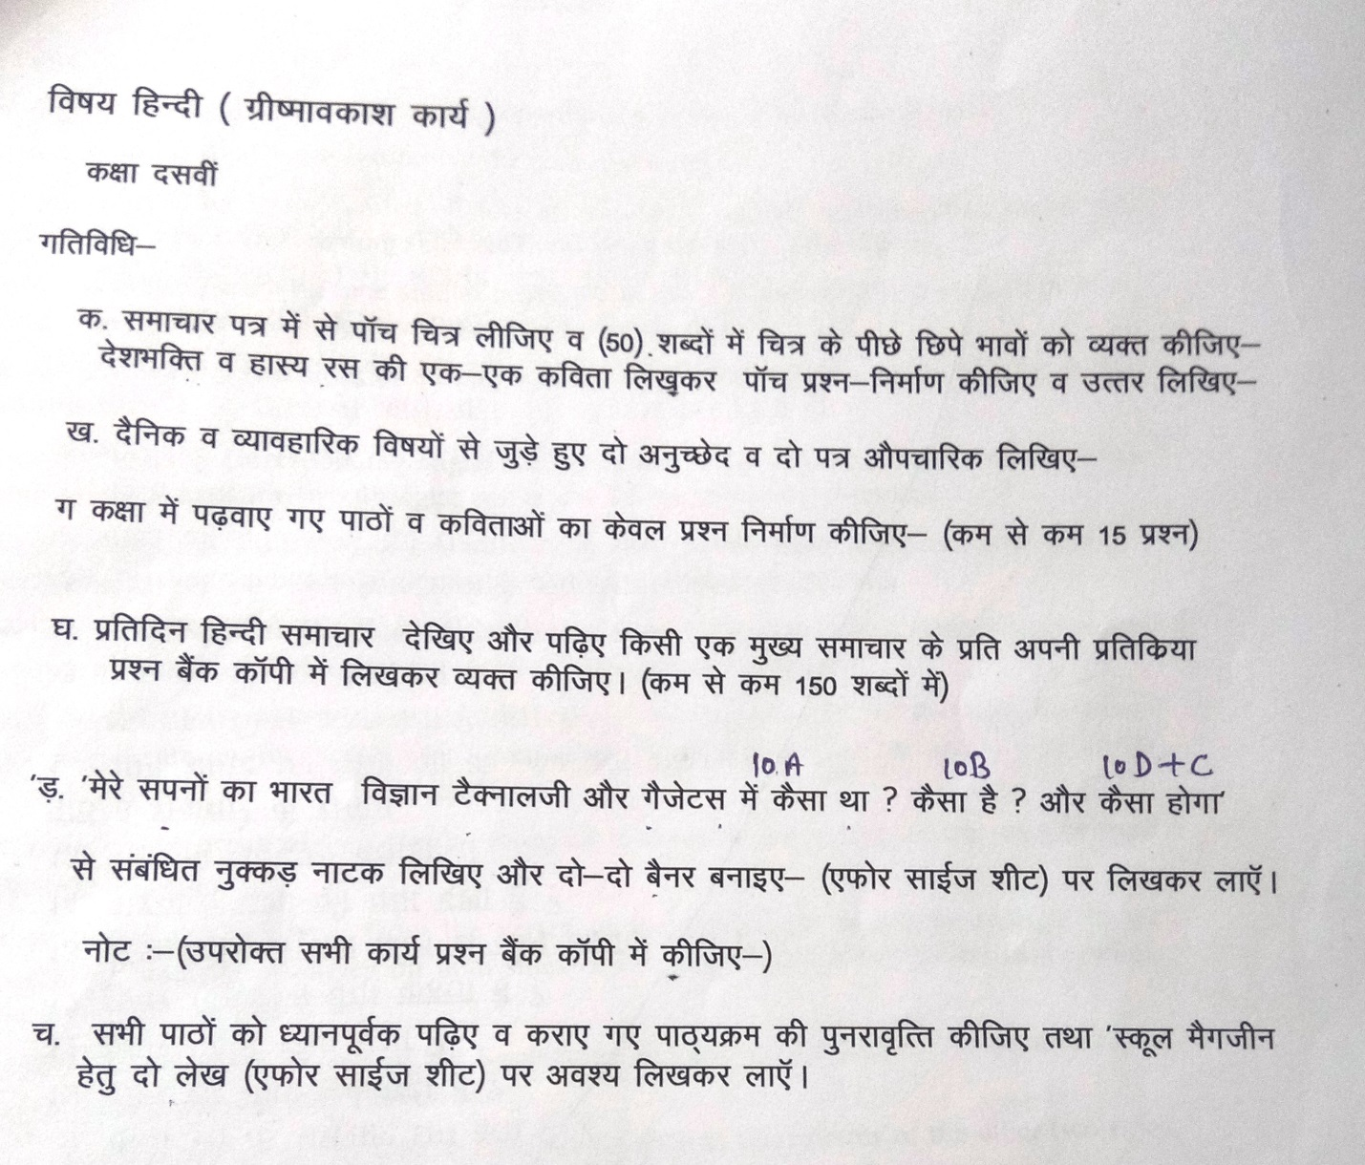

SUBJECT: MATHEMATICS
CLASS: X
Holidays Home work (2018-2019)
Topics : Trigonometry & Statistics

Trigonometry

Section A (1 Mark Questions)
1. Find the value of
2. If
3. What is the value of 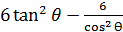
4. If 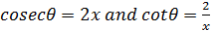find the value of

Section B (2 Marks Questions)
5. If
6. If sinθ = 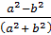 Find the value of tan θ.
7. Find the value of
8. If
9. Find the value of 3.
10. Find the value of Sin75°, using the relation Sin(A+B) = sinA cosB + cosA sinB

Section C (3 Marks Questions)
11. tan A= √2-1, show that sinA.cosA=
12. If tan A =1 and tanB= √3 , evaluate cosAcosB - sinAsinB
13. In a right triangle ABC, right angled at B, the ratio of AB to AC is 1:√2. Find the value of 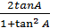
14. If 3tanθ = 4, find the value of 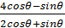
15. Find the value
16. Find an acute angle θ, when 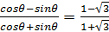
17. Evaluate + 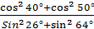
18. Find the value of tan 1° tan 2° tan 3°….. tan 89°
19. Find the value of cos 1°cos 2° cos 3°…. cos 180°
20. If A+B = 90°, prove that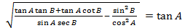

Section D (4 Marks Questions)
Prove the following identies:

21.
22.
23.
24.
Statistics
Section A

1. Obtain the mode for the following frequency distribution.

x | 5 | 6 | 7 | 8 | 9 | 10 | 11 | 12 | 13
f | 8 | 12 | 13 | 14 | 13 | 11 | 7 | 4 | 3

2. The shirt worn by a group of 200 persons who bought the shirt from a store are as follows:
Shirt size | 37 | 38 | 39 | 40 | 41 | 42 | 43 | 44
No. of person | 15 | 25 | 39 | 41 | 36 | 17 | 15 | 12
What is the mode size of shirt?

3. Find x if the mean of x, x+3, x+6, x+9 and x+12 is 10.
4. If the median of the data 6, 7, x-2, x, 17, 20 written in ascending order is 16, Find x.
5. Find median of first 10 prime numbers.
6. If the mode of the data 64, 60, 48, x, 43, 48, 43, 34 is 43, then find the value of x+3.

Section B (2 Marks Questions)

7. Obtain the median for the following frequency distribution.

x | 1 | 2 | 3 | 4 | 5 | 6 | 7 | 8 | 9
f | 8 | 10 | 11 | 16 | 20 | 25 | 15 | 9 | 6

8. Find the value of k if the mean of a frequency distribution is 8.1 and ∑ f_{i}x_{i} = 132+5k, ∑f_{i} = 20

9. Write empirical formula and using that find the value of mean of the data if it is given that median =52 and mode = 50.
10. Write frequency table of the following distribution.

Marks(more than or equal to) | 0 | 10 | 20 | 30 | 40 | 50
No. of students | 63 | 58 | 55 | 51 | 48 | 42

Section C (3 Marks Questions)

11. The mean of the following data is 18.75. Find the value of p.
Class mark | 10 | 15 | p | 25 | 30
Frequency | 5 | 10 | 7 | 8 | 2

12. Compute the median from the following data:

Mid value | 115 | 125 | 135 | 145 | 155 | 165 | 175 | 185 | 195
Frequency | 6 | 25 | 48 | 72 | 116 | 60 | 38 | 22 | 3

13. Find the mean of following distribution

Marks | 5 | 10 | 15 | 20 | 25 | 30 | 35 | 40 | 45 | 50
No. of students | 15 | 50 | 80 | 76 | 72 | 45 | 39 | 9 | 8 | 6

14. Compute the mode from the following data:
Size of item | 0-4 | 4-8 | 8-12 | 12-16 | 16-20 | 20-24 | 24-28 | 28-32 | 32-36 | 36-40
frequency | 5 | 7 | 9 | 17 | 12 | 10 | 6 | 3 | 1 | 0

Section D (4 Marks Questions)

15. The median of the following data is 525. Find the value of x and y, if the total frequency is 100.
Class Interval | 0-100 | 100-200 | 200-300 | 300-400 | 400-500 | 500-600 | 600-700 | 700-800 | 800-900 | 900-1000
Frequency | 2 | 5 | x | 12 | 17 | 20 | y | 9 | 7 | 4
16. Draw a more than type ogive for the data given below which gives the marks of 100 students and hence find the median marks.
Marks | 0-10 | 10-20 | 20-30 | 30-40 | 40-50 | 50-60 | 60-70 | 70-80
Students | 4 | 6 | 10 | 10 | 25 | 22 | 18 | 5
17. The following table gives the literacy rate (in %) in 40 cities. Find the mean literacy rate using step deviation method.
Literacy rate (%) | 45-55 | 55-65 | 65-75 | 75-85 | 85-95
No. of cities | 4 | 11 | 12 | 9 | 4

18. Find the missing frequency in the following frequency distribution if mean of the data is 1.46
No. of accidents | 0 | 1 | 2 | 3 | 4 | 5 | Total
Frequency | 46 | x | y | 25 | 10 | 5 | 200

19. Find mean and median of marks of the students

Below10 | Below20 | Below30 | Below40 | Below50 | Below60 | Below70 | Below80 | Below90 | Below 100
5 | 9 | 17 | 29 | 45 | 60 | 70 | 78 | 83 | 85

Match duration | 25-28 | 30-33 | 35-38 | 40-43 | 45-48 | 50-53 | 55-58
No. of matches | 14 | 22 | 16 | 6 | 5 | 3 | 4
20. The following table gives the match durations of Badminton matches played in a tournament . Find the mean match duration using step deviation method.
Profits (in lakhs in Rs.) | Number of shops
More than equal to 5 | 30
More than equal to 5 | 28
More than equal to 5 | 16
More than equal to 5 | 14
More than equal to 5 | 10
More than equal to 5 | 7
More than equal to 5 | 3
21. The annual profits earned by 30 shops of a shopping complex in a locality were given in following table.

Draw both typies of Ogives for the above data and hence obtain the median.
Hots questions

- The mean of first n odd natural numbers is find n.
- If the difference of mode and median of a data is 24 then what is the difference of median and mean?
- The mean of 1,3,4,5,7,4 is m. The numbers 3,2,2,4,3,3 and p have mean m-1 and median q. Then find p + q
- If then find .
- If mode of series exceeds its mean by 12, then find the value by which mode exceeds the median.

PHYSICS
CH -SOURCES OF ENERGY
GIST OF THE LESSON
1. A good source of energy is one that is able to provide large amount of work per unit volume or mass, be easily accessible at economical rate and can be easily stored and transported.
2. Conventional sources of energy: Fossil fuels, coal, petroleum, natural gas (thermal power plants), energy of flowing water (hydrowater plants), biomass, cow-dung, plants and vegetable wastes (bio-gas plants), wind energy (windmill).
3. Fossil fuels: Any naturally occurring organic fuel formed in the Earth’s crust, such as petroleum, coal and natural gas are called fossil fuels.
4. Alternate or non-conventional sources of energy:
Solar
energy-energy derived from sun, Nuclear energy-fission of radioactive substances, Geo-thermal energy-energy derived from hot spots under the earth, Ocean energy-ocean thermal energy, wave energy.
5. Non-renewal sources of energy: Fossil fuels like coal, petroleum and natural gas non-renewable.
6. Thermal power plants: Thermal power plants should be preferably located near coal or oil fields. It is easier to transport electricity than the fuel.
7. Hydropower plants: Convenient location to build dams. Potential energy of falling water is converted into electricity.
8. Biomass: The plant and animal products, which act as the source of fuel is said to be biomass.
9. Biogas: Cow-dung, various plants materials like the residue after harvesting the crops, vegetable waste and sewage decomposed in the absence of oxygen to give biogas (or Gober gas).
10 Biogas plants: Anaerobic micro-organisms (in the absence of oxygen) decompose complex compounds of cow-dung slurry or biomass-water mix produce biogas (60-80% methane).
11. Tidal energy: The gravitational pull of the moon on the rotating earth causes rise and fall in the level of water in the sea. The sea-level changes during the day. This phenomenon is called high and low tides and difference in sea levels gives us tidal energy. Tidal energy is harnessed by constructing a dam across narrow opening to the sea. A turbine fixed at the opening of the dam converts tidal energy to electricity.
12. Windmill: The power of wind (>15km/h) gives rotatory motion of the windmill which is used to turn the turbine of the electric generator. The output of a single windmill is quite small and so a number of windmills are to be erected over a large area.
13. Nuclear reactor is a device in which a fission reaction is carried out in a controlled manner. The energy so released is used to heat water which then turns turbines and generates electricity. (Note: Fission of heavy radioactive isotopes gives tremendous amount of energy.)
14. Environment consequences: Sources of energy as are available produce lot of pollution in the atmosphere or cause environmental damage in other ways.
15. Quality of fuel is measured by its calorific value (heat regenerated by burning unit mass of a substance
16. Solar energy: 47% of the sun’s energy reaching the periphery of the earth’s atmosphere reaches the earth’s surface. One m2 of earth’s surface receives 1.4kJ/m2s. This is called solar constant. This energy is trapped by various means such as solar cookers, solar heaters and solar cells. A typical solar cell (using high quality silicon or silver) develops a voltage of 0.5-1V and can produce 0.7W of electricity. So a panel of solar cells is used.
VERY SHORT QUESTIONS WITH ANSWERS (1 MARK)

Q.1. Name the largest component of biogas.
Ans. The largest component (upto75%) of biogas in methane.
Q.2. What is greenhouse effect?
Ans. The glass roof and glass walls of a greenhouse allow heat and sunlight to enter it but do not allow heat (infrared radiation) to escape. On account of this, greenhouse gets warmed.
Q.3. Name the gaseous fuel, out of the following which has the highest calorific value: Hydrogen, Methane, LPG, Biogas
Ans. Hydrogen.
Q.4.Why is CNG considered an environmental friendly fuel?
Ans. CNG does not produce toxic gases on burning.
Q.5. Name a fraction obtained during refining of petroleum which does not find use as a fuel.
Ans. Lubricating oil.
Q.6. Which of the following gases is a major constituent of biogas : Carbon monoxide, hydrogen, methane, carbon dioxide?
Ans. Methane (75%)
Q.7. What is slurry left over after generation of biogas in biogas plant used?
Ans. The slurry is rich in nitrogenous and phosphorus compounds and as such serves as an excellent manure.
Q.8. How is the increase in demand for energy affecting our environment adversely ?
Ans. We use fossil fuels to meet the increased energy demands. As a result of this, pollutants so produced adversely change the composition of the environment.
Q.9. Name the process by which energy is produced in a nuclear reactor.
Ans. In a nuclear reactor,energy is produced by the process of nuclear fission.
Q.10. Which one of the following is a renewable resource: Natural gas, petroleum, Ground water, Coal
Ans. Ground water.
MCQ on SOURCES OF ENERGY
Q.1. Choose the incorrect statement regarding wind power:
(a) It is expected to harness wind power to minimum in open space.
(b) The potential energy content of wind blowing at high altitudes is the source of wind power.
(c) Wind hitting at the blades of a windmill causes them to rotate. The rotation thus achieved can be utilized further
(d) One possible method of utilizing the energy of rotational motion of the blades of a windmill is to run the turbine of an electric generator.
Ans (b)
Q.2. Acid rain happens because:
(a) sun leads to heating of upper layer of atmosphere.
(b) burning of fossil fuels release oxides of carbon, nitrogen and sulphur in the atmosphere.
(c) electrical charges are produced due to friction amongst clouds.
(d) earth atmosphere contains acids.
Ans . (b)
Q.3. In a hydro power plant
(a)potential energy possessed by stored water is converted into electricity.
(b) kinetic energy possessed by stored water is converted into potential energy.
(c) electricity is extracted from water.
(d) water is converted into steam to produce electricity.
Ans. (a)
Q.4. which one of the following forms of energy leads to least environmental pollution in the process of its harnessing and utilization?
(a)nuclear energy (b) thermal energy (c) solar energy (d) geothermal energy
Ans. (c)
Q.5. Which of the following is a non-renewable source of energy?
(a)wood
(b)sun
(c)fossil fuels
(d) wind
Ans .(c)
Q.6. Ocean thermal energy is due to
(a) energy stored by waves in the ocean
(b) temperature difference at different levels in the ocean
(c) pressure difference at different levels in the ocean.
(d) tides arising out in the ocean.
Ans .(b)
Q.7. the major problem in harnessing nuclear energy is how to:
(a) split nuclei.
(b) sustain the reaction.
(c)dispose off spent fuel safely.
(d) convert nuclear energy into electrical energy.
Ans.(c)
Q.8. which is the ultimate source of energy?
(a) water
(b) sun
(c ) uranium
(d) fossil fuels
Ans. (b)
Q.9. The main constituent of biogas is
(a) methane
(b) carbon dioxide
(c) hydrogen
(d)hydrogen sulphide.
Ans.(a)
Q.10. the power generated in a windmill:
(a) is more in rainy season since damp air would mean more air mass hitting the blades.
(b) depends on the height of the tower.
(c) depends on wind velocity.
(d) can be increased by planting tall trees close to the tower.
Ans . (c)
Q.11. choose the correct statement:
(a)Sun can be taken as an inexhaustible source of energy.
(b) There is infinite storage of fossil fuel inside the earth.
(c) Hydro and wind energy plants are non polluting sources of energy.
(d) Waste from a nuclear power plant can be easily disposed off.
Ans.(a)
Q12. which part of the solar cooker is responsible for green house effect?
(a) coating with black colour inside the box
(b) mirror
(c) glass sheet.
(d) outer cover of the solar cooker
Ans.(c)
Q.13. In a hydroelectric power plant more electrical power can be generated if water falls from a greater height because:
(a) its temperature increases. (b) larger amount of potential energy is converted into kinetic energy. (c) the electricity content water increases with height. (d) more water molecules dissociate into ions. Ans. (b).
Q.14. choose the incorrect statement:
(a) We are encouraged to plant more trees so as to ensure clean environment and also provide bio-mass fuel.
(b) Gober-gas is produced when crops,vegetable wastes etc.,decompose in the absence of oxygen.
(c) The main ingredient of bio-gas is ethane and it gives a lot of smoke and also produces a lot of residual ash.
(d) Bio-mass is a renewable source of energy.
Ans.(c)
Q.15. Fuel used in thermal power plants is
(a) water (b) uranium (c) biomass (d) fossil fuels
Ans. (d)
Short answertype questions .
Q1.what are the advantages of fossil fuel?
what are the advantages of hydro energy fuel?
what are the advantages of biomass energy?
what are the advantages of wind energy?
what are the advantages of energy from ocean?
what are the advantages of geothermal energy?
what are the advantages of nuclear energy?
what are the advantages of solar energy?

What are the limitations wind energy
What are the limitations solar energy
What are the limitations geothermal energy
What are the limitations energy from sea
What are the limitations biomass energy
What are the limitations hydro energy
What are the disadvantages of fossil fuel?
What are the disadvantages of using nuclear energy?
What is meant by indirect utilisation ofsolarenergy?
Usage of hydro energy disturbs the ecological balance.comment
Compare nuclear fission and fusion.
Q2.Long answer type(3 marks)
Q1.explain with the help of diagram the working of biogas plant.
Q2. explain with the help of diagram the working of OTEC plant.
Q3.explain nuclear fission and fusion processes.
Q 4.Explain the construction of solar cooker with the help of a diagram
Q5.How were coal and petroleum formed?

SUBJECT-CHEMISTRY

1.Match the acids given in Column (A) with their correct source given in Column (B)
Column (A) Column (B)
(a) Lactic acid (i) Tomato
(b) Acetic acid (ii) Lemon
(c) Citric acid (iii) Vinegar
(d) Oxalic acid (iv) Curd
2. Match the important chemicals given in Column (A) with the chemical formulae given in Column (B)
Column (A) Column (B)
(a) Plaster of Paris (i) Ca(OH)2
(b) Gypsum (ii) CaSO4.1/2 H2O
(c) Bleaching Powder (iii) CaSO4.2H2O
(d) Slaked Lime (iv) CaOC12
3. What will be the action of the following substances on litmus paper?
Dry HCl gas, Moistened NH3 gas, Lemon juice, Carbonated soft drink, Curd, Soap solution.
4. Name the acid present in ant sting and give its chemical formula. Also give the common method to get relief from the discomfort caused by the ant sting.
5. What happens when nitric acid is added to egg shell?
6. A student prepared solutions of (i) an acid and (ii) a base in two separate beakers. She forgot to label the solutions and litmus paper is not available in the laboratory. Since both the solutions are colourless, how will she distinguish between the two?
7. How would you distinguish between baking powder and washing soda by heating?
8. Salt A commonly used in bakery products on heating gets converted into another salt B which itself is used for removal of hardness of water and a gas C is evolved. The gas C when passed through lime water, turns it milky. Identify A, B and C.
9.In one of the industrial processes used for manufacture of sodium hydroxide, a gas X is formed as by product. The gas X reacts with lime water to give a compound Y which is used as a bleaching agent in chemical industry. Identify X and Y giving the chemical equation of the reactions involved.
10. Fill in the missing data in the following table
Name of the salt | Formula | Salt obtained from
Name of the salt | Formula | ACID | BASE
(i) Ammonium chloride | NH4Cl | NH4OH
(II)Copper sulphate |  | H2SO4
(iii) Sodium chloride | NaCl | NaOH
iv) Magnesium nitrate | Mg (NO3 )2 | HNO3
(v) Potassium sulphate | K2 SO4
(vi) Calcium nitrate | Ca(NO3)2 | Ca(OH)2

11.What are strong and weak acids? In the following list of acids, separate strong acids from weak acids.
Hydrochloric acid, citric acid, acetic acid, nitric acid, formic acid ,sulphuric acid.

12. When zinc metal is treated with a dilute solution of a strong acid,a gas is evolved, which is utilised in the hydrogenation of oil. Name the gas evolved. Write the chemical equation of the reaction involved and also write a test to detect the gas formed.

13.For making cake, baking powder is taken. If at home your mother uses baking soda instead of baking powder in cake,
(a) how will it affect the taste of the cake and why?
(b) how can baking soda be converted into baking powder?
(c) what is the role of tartaric acid added to baking soda?

14. A metal carbonate X on reacting with an acid gives a gas which when passed through a solution Y gives the carbonate back. On the other hand, a gas G that is obtained at anode during electrolysis of brine is passed on dry Y, it gives a compound Z, used for disinfecting drinking water. Identity X, Y, G and Z.

15. A dry pellet of a common base B, when kept in open absorbs moisture and turns sticky. The compound is also a by–product of chloralkali process. Identify B. What type of reaction occurs when B is treated with an acidic oxide? Write a balanced chemical Equation for one such solution.

16. A sulphate salt of Group 2 element of the Periodic Table is a white ,soft substance, which can be moulded into different shapes by making its dough. When this compound is left in open for some time, it becomes a solid mass and cannot be used for moulding purposes. Identify the sulphate salt and why does it show such a behaviour? Give the reaction involved.

17. Identify the compound X on the basis of the reactions given below.
Also, write the name and chemical formulae of A, B and C.
ZZZZZZZZZZZZZZZZZZZZZZZ
xxxx
//

Multiple Choice Questions
1. What happens when a solution of an acid is mixed with a solution of a base in a test tube?
(i) The temperature of the solution increases
(ii) The temperature of the solution decreases
(iii) The temperature of the solution remains the same
(iv) Salt formation takes place
(a) (i) only (b) (i) and (iii)
(c) (ii) and (iii) (d) (i) and (iv)
2. An aqueous solution turns red litmus solution blue. Excess addition of which of the following solution would reverse the change?
(a) Baking powder
(b) Lime
(c) Ammonium hydroxide solution
(d) Hydrochloric acid
3. During the preparation of hydrogen chloride gas on a humid day,the gas is usually passed through the guard tube containing calcium chloride. The role of calcium chloride taken in the guard tube is to
(a) absorb the evolved gas
(b) moisten the gas
(c) absorb moisture from the gas
(d) absorb Cl– ions from the evolved gas
4. Which of the following salts does not contain water of crystallisation?
(a) Blue vitriol
(b) Baking soda
(c) Washing soda
(d) Gypsum
5.Sodium carbonate is a basic salt because it is a salt of
(a) strong acid and strong base
(b) weak acid and weak base
(c) strong acid and weak base
(d) weak acid and strong base
6. Calcium phosphate is present in tooth enamel. Its nature is
(a) basic
(b) acidic
(c) neutral
(d) amphoteric
7. A sample of soil is mixed with water and allowed to settle. The clear supernatant solution turns the pH paper yellowish-orange .Which of the following would change the colour of this pH pape rto greenish-blue?
(a) Lemon juice
(b) Vinegar
(c) Common salt
(d) An antacid
8. Which of the following gives the correct increasing order of acidic strength?
(a) Water <Acetic acid <Hydrochloric acid
(b) Water <Hydrochloric acid <Acetic acid
(c) Acetic acid <Water <Hydrochloric acid
(d) Hydrochloric acid <Water <Acetic acid
9. If a few drops of a concentrated acid accidentally spills over the hand of a student, what should be done?
(a) Wash the hand with saline solution
(b) Wash the hand immediately with plenty of water and apply a paste of sodium hydrogencarbonate
(c) After washing with plenty of water apply solution of sodium hydroxide on the hand
(d) Neutralise the acid with a strong alkali
10. Sodium hydrogencarbonate when added to acetic acid evolves a gas. Which of the following statements are true about the gas evolved?
(i) It turns lime water milky
(ii) It extinguishes a burning splinter
(iii) It dissolves in a solution of sodium hydroxide
(iv) It has a pungent odour
(a) (i) and (ii) (b) (i), (ii) and (iii)
(c) (ii), (iii) and (iv) (d) (i) and (iv)
11. Which of the following is(are) true when HCl (g) is passed through water?
(i) It does not ionise in the solution as it is a covalent compound.
(ii) It ionises in the solution
(iii) It gives both hydrogen and hydroxyl ion in the solution
(iv) It forms hydronium ion in the solution due to the combination of hydrogen ion with water molecule
(a) (i) only (b) (iii) only
(c) (ii) and (iv) (d) (iii) and (iv)
12. Which of the following statements is true for acids?
(a) Bitter and change red litmus to blue
(b) Sour and change red litmus to blue
(c) Sour and change blue litmus to red
(d) Bitter and change blue litmus to red
13. Which of the following are present in a dilute aqueous solution of hydrochloric acid?
(a) H3O+ + Cl–
(b) H3O+ + OH–
(c) Cl– + OH–
(d) unionised HCl
14. Identify the correct representation of reaction occurring during chloralkali process
(a) 2NaCl(l) + 2H2O(l) → 2NaOH(l) + Cl2(g) + H2(g)
(b) 2NaCl(aq) + 2H2O(aq) → 2NaOH(aq) + Cl2(g) + H2(g)
(c) 2NaCl(aq) + 2H2O(l) → 2NaOH(aq) + Cl2(aq) + H2(aq)
(d) 2NaCl (aq) + 2H2O (l) → 2NaOH (aq) + Cl2(g) + H2(g)
15. Which one of the following can be used as an acid–base indicator by a visually impaired student?
(a) Litmus
(b) Turmeric
(c) Vanilla essence
(d) Petunia leaves
16. Which of the following substance will not give carbon dioxide on treatment with dilute acid?
(a) Marble
(b) Limestone
(c) Baking soda
(d) Lime
19. Which of the following is acidic in nature?
(a) Lime juice
(b) Human blood
(c) Lime water
(d) Antacid
20.To protect tooth decay we are advised to brush our teeth regularly. The nature of the tooth paste commonly used is
(a) acidic
(b) neutral
(c) basic
(d) corrosive
BIOLOGY :
Go through the study material provided and answer the questions that are given as a small question bank:
OUR ENVIRONMENT
- Environment means everything which surrounds us. It may include living (biotic) and non-living (abiotic) components.
- Biotic : Plants and animals. Abiotic : Air, water etc.
- Environment affect the life and development of an organism in its natural habitat & vice a versa.
- Substances that can be decomposed by the action of micro-organism like bacteria are called bio-degredable. E.g. organic wastes
- Substances which cannot be decomposed by the action of microorganisms are called non-biodegradable.
- Example of biodegradable wastes : cattle dung, cotton, jute, paper, fruit and vegetable peels, leaves etc.
- Examples of non-biodegradable wastes : plastics, polythene bags, synthetic fibres, glass, metals, radioactive wastes.
ECO SYSTEM & ITS COMPONENT
- All the interacting living organisms in an area together with non living components form an ecosystem. So an ecosystem consists of both biotic(living creatures) and abiotic components like temperature, rainfall, wind, soil etc.
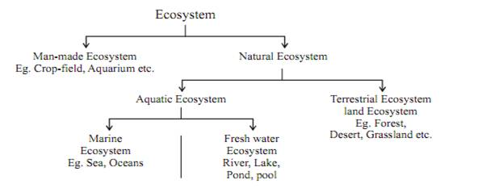
- All living organisms are classified on the basis nutrition.
I. Producers : All green plants, blue green algae can produce their food (Sugar & starch) from inorganic substance using light energy (Photosynthesis).
II. Consumers : Include organisms which depend on the producers either directly or indirectly for their sustenance. Consumers depend on others for food.
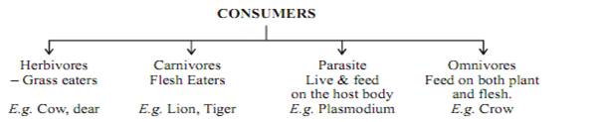
III. Decomposeres : Fungi & Bacterias which break down(decompose) the dead plant,
animals complex organic molecules into the simpler inorganic ones. Thus decomposeres help in the replenishment of minerals in soil, clean the environment.

A 3- Step Food Chain
- Food Chain : It is the sequence of living organisms in which one organism consumes another organism for energy. It is unidirectional(single directional).
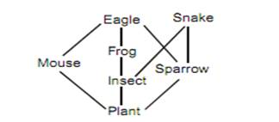
- In a food chain, various steps where transfer of energy takes place is called a trophic level.Trophic level is also defined as every step of food chain. It tells the functional role of an organism in the food chain.
- The green plants capture 1% of sun’s energy.
- The flow of energy is unidirectional in a food chain.
- There is gradual decrease in the amount of energy from one trophic level to next trophic level in a food chain.
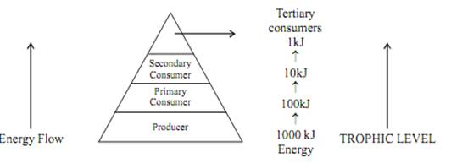
- 10 Percent Law : The energy available at each successive trophic levelis 10% of the previous level.
So only 10% of Energy is transferred to next trophic level while 90%of energy is used by present trophic level in its life processes.So shorter the food chain more beneficial it will be for the organisms.
Biomagnification: The concentration of harmful chemical ( pesticides, heavy metals etc) increases with every next trophic level in a food chain. It is called Bio-magnification .Maximum concentration of such chemicals get accumulated in human bodies. Since humans occupy the top level in any food chain.
Harmful chemicals can not be excreted nor they can be metabolised, but can only be passed on from one trophic level to next higher trophic level of food chain, therefore causing biomagnification.

ENVIRONMENTAL PROBLEMS
- Changes in environment affect us and our activities change the environment around us. Environmental problems caused by humans:
(a) depletion of the Ozone Layer and waste disposal.
(b) pollution due to mismanagement of waste disposal.
I. Depletion of Ozone Layer
- Ozone (O3) layer is largely found in the stratosphere which is a part ofour atmosphere from 12 km – 50km above sea level.
- Ozone is a deadly poison at the ground level.
- Ozone is formed as a result of a following photochemical reaction.
O₂ UV O + O
O₂ + O O3
- Ozone layer is a protective blanket around earth which absorbs most of the harmful U.V. (Ultraviolet) radiation of the Sun, thus protecting the living beings of the earth from health hazards like skin cancer, cataract in eyes, weaken immune system, destruction of plants etc.
- The decline of Ozone layer thickness in Antartica was first observed in 1985 and was termed as OZONE HOLE.
Reason of Ozone Depletion
Excessive use of CFCs (Chloro Flouro Carbon) a synthetic, inert chemical E.g. Freon which are used as refrigerants and in fire extinguishers, caused Ozone depletion in the upper atmosphere. A single chlorine atom can destroys 1,00,000 Ozone molecules. U.N.E.P. (United Nation Environment Programme)did an excellent job in forging an agreement to freeze CFC production at 1986 levels (KYOTO Protocol) by all countries.
Garbage Disposal
Industrialization and rise in demand of consumer goods have created a major problem in the form of wastes/garbage accumulation and its disposal specially in urban area.
The different methods of solid wastes disposal commonly used around
the world are.
1. Open dumping : A conventional method in which solid wastes dumped in selected areas of a town. It actually cause pollution
2. Land fillings : Wastes are dumped in low living area and are compacted by rolling with bulldozers
Composting : Organic wastes are filled into a compost pit (2m × 1m× 1m). It is then covered with a thin layer of soil. After about three months the same garbage filled inside the pit changes into organic manure.
4. Recycling : The solid wastes is broken down into its constituent simpler materials. These materials are then used to make new items. Even non-bio degradable solid wastes like plastic, metal can be recycled.
5 Reuse : A very simple conventional technique of using an item again& again. For e.g. paper can be reused for making envelops etc.

VSA Questions :
  - Which type of organisms occupy the first trophic level of a food chain?
  - Which bag would you prefer for shopping and why?
    - Jute bag
    - Polythrne bag
  - Mention the significance of trophic level in a food chain.
  - Ozone layer is important for existence of life on Earth. Justify.
  - Expand the term CFC and UNEP.
  - Define ozone hole.
  - Paper cups are preferred over plastic cups. Why?
  - What is meant by reuse strategy?
  - Name the bacteria by which presence one can detect the pollution status in water.

SA Questions:

- Differentiate between biodegradable and non-biodegradables wastes with proper examples.
- What are trophic levels? Draw a food chain and state the different trophic levels in it.
- What will happen if all the organisms in a particular trophic level of a food chain are killed?
- Draw an energy pyramid showing different trophic levels in it.
- How can we help in reducing the problem of waste disposal? Give two ways.
- Enlist the roles played by decomposers in the environment.
- Study the food chains given below:
      - Grass Grasshopper Frog
      - Wheat Rat Snake Hawk
Which of the two consumers frog/ Hawk will get more energy and why?
- What is meant by 10% law? Calculate the energy available to the hawk in the given food chain if energy received by sun to producers is 10000000J.
Wheat Rat Snake Hawk.
- Energy can transfer from one trophic level to next higher trophic level in a food chain but never in a reverse direction. Why?
- Differentiate between members of first trophic level and members of second trophic level of a food chain with respect to feeding habits with appropriate examples.

VLA questions :

- (a) Define food chain. Give an example of food chain in a grassland ecosystem.
(b) Give two points of difference between food chain and food web.
(c) How is energy transferred in a food chain? Discuss.
2. (a) How harmful chemicals like pesticide enter into our body? Also give the technical term for the phenomenon.
(b) Why concentration of harmful chemicals increases while energy level decreases from lower to higher level in a food chain.
3. You are an active member of eco-club. Give five ways of solid waste management to the people of your society .

