Transforming Education Awards – Teacher Awards’ for 2018 from Lovely Professional University, Punjab

Dear Sir/ Ma'am,

Greetings from Lovely Professional University!!
Subject- Nominations for ‘Transforming Education Awards – Teacher Awards’ for 2018
“I am not a Teacher, but an Awakener”. This quote of Robert Frost truly reflects the role that a teacher plays in the life of the students. Every person in this world has been shown some guiding light by one or more inspiring teachers. Recognising this never ending contribution of all the teachers in this world, Lovely Professional University initiated ‘Transforming Education Awards’ last year.

I am pleased to share with you that the first edition of ‘Transforming Education Awards’ was a huge success as more than 3500 nominations were received and approximately 6 lakh students, parents and other persons voted for their teachers. You will also be happy to know that the final awards were given by Shri Pranab Mukherji, Former President of India and the award ceremony was held at his residence in Delhi.

With great pleasure, Lovely Professional University invites you to be the part of 2nd Edition of Transforming Education Awards. The awards this year will be given to the teachers who have made an impact in the lives of the students or who have contributed in some way to make our surroundings a better place to live.

We look forward for your cooperation, association and participation by nominating the most able teachers for this award. The detailed process and other highlights including glimpses of last year's award ceremony are attached for your reference.
Kindly provide us an appointment so that we can explain all the necessary information related with participation in this Education Award. An early appointment will be highly appreciated as the last date of voting will close by 2nd week of December.

--
Best Regards

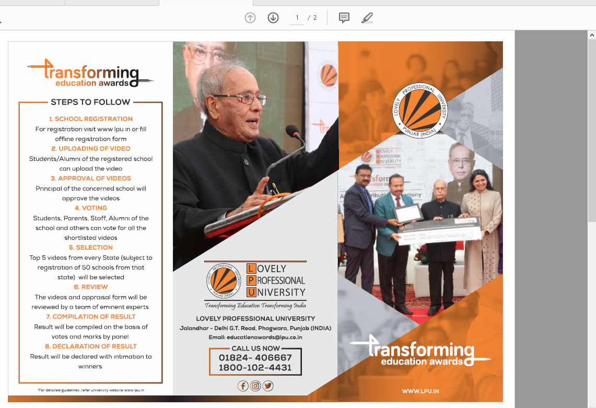

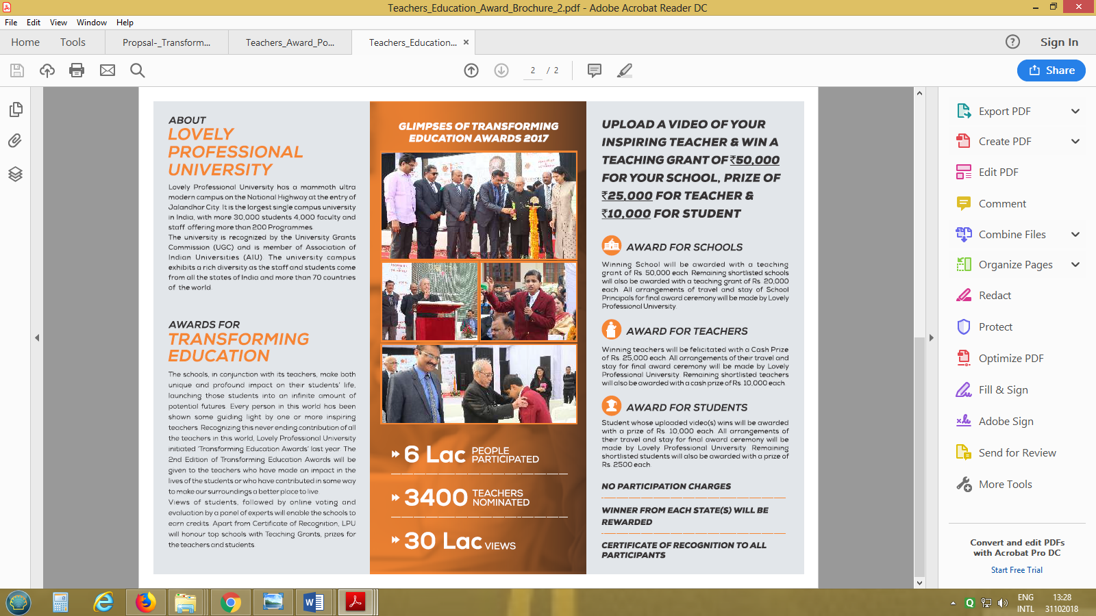

Transforming Education Awards - Proposal

A. Who Can Participate: Any student from class 8thand onwards can upload the video. The student/s can participate individually or in group of maximum 5 students.

B. Shortlisting: Top 5 videos from every State will be shortlisted (subject to registration of 50 schools from that state) in Teacher Award category. The shortlisted nominees will be required to submit an appraisal form duly approved by School Principal. In case the number of videos from a particular State/s are less than 50, those states will be merged to form a group for the shortlisting of videos and final awards.

C. The awards will be given in following two categories:

a. Teacher Award: The students can make video a showing how a teacher has contributed in transforming the students’ lives. The students can quote specific examples and cases in support of the claims made in the video. Any or all of the following themes may be highlighted in the video:

i. Innovative Teaching:The teachers’ imagination in making the studies interesting,inspirational
stories, Positive impact on students’ learnings will be recognised.

ii. Inspirational Teacher: Each one of us has been inspired by a teacher who acted as a guiding light in shaping our futures. Any such teacher, who has inspired students to achievesomething big or has helped students in transforming their lives may be nominated for the award.

iii. Tech Savvy Teacher: The integration of technology by the teacher in improving the teaching pedagogy and making an impact on student learnings. The parameters like how technology has been integrated in regular teaching, how technology is improving student learning, use of technology outside classroom etc. will be considered for giving the award.

iv. Outstanding contribution to Community: The teacher’s contribution to the community and making the students as more responsible citizens can be highlighted. The efforts of the teacher in outstanding, sustained and continuous engagement with community will be some of the parameters of judgement.

v. Rising Teacher: The fresh and passionate approach of a new teacher always bring something novel in and outside class. The teachers who have joined this profession in last 5 years and are making a significant and inspirational impact in students’ life may be nominated for the award.

b. Life Time Achievement Award (Direct Selection by Jury, no nominations to be received from schools/colleges etc.): The award will be the recognition of services of an Individual or Organisation that has made a significant impact in the field of education.

D. Prizes:Teaching grant or Cash Prizes will be given as per following criteria:

Table: Award Categories

Category | Number | School
WINNERS- School (Teacher Award) | 20 | ₹ 50,000
WINNERS- Teacher (Teacher Award) | 20 | ₹ 25,000
WINNERS- Student (Teacher Award) | 20 | ₹ 10,000
Shortlisted- School (Teacher Award) | 80 | ₹ 20,000

Shortlisted Teacher (Teacher Award) | 80 | ₹ 10,000
Shortlisted- Student (Teacher Award) | 80 | ₹ 2,500

Important Points (Schools)

1. Registration:

a. How to register:

i. Option 1: School can register by filling the registration form available online on website or by filling offline registration form available with LPU representatives.

ii. Option 2: The student/alumnican request for registration of the school online by filling details
on the website. The organising team will contact the school to complete the registration process. The registration process will be considered as complete only when the request is duly approved after verification of all details and consent has been given by school authorities.

b. The uploaded videos will only be visible for voting once the registration is formally completed and video is approved both by School authorities and Organising body.

2. Award Categories:

a. The schools can participate in Teacher Award category. The themes mentioned are for reference and should be treated as separate categories or sub-categories.

3. Videos:

a. The school can participate in Teacher Award category only. b. Length of the Video: 2-5 Minutes.
c. The school can upload maximum 4 videos.
d. The video can be any format and graphics, pictures, animations or any other suitable techniques can be used to make the video moremeaningful and attractive.
e. The language to be used in video should be English or Hindi only. Any video in other languages will
be disqualified.
f. Any Student/Alumni can upload the video.
g. The uploaded videos will be available for voting only when the same is approved by school authorities and LPU.

The videos may be modified to include LPU or event logo at the beginning, during or end of the video.

4. Voting:
a. The approved videos will be available on university website, university Facebook page or any other social media for voting.
b. The final votes will include votes on website, likes on Facebook, Twitter, Instagram or any other
social media.
c. All the shortlisted videos are available for viewing under the head Nominees. You can vote for a particular video by any of the following methods:

i. Voting through Website#
• Step I: Press the vote button on the video you like.
• Step II: Enter your name and mobile number in the pop-up.
• Step III: Enter the OTP received on your mobile.
• Step IV: Submit your vote.

ii. Voting through SMS#

• Step I: Type AWARDS followed by the Id of the video you like.
For example: AWARDS TPSA100011
• Step II: Send SMS to 7834830000

Note: #From one mobile number, you can cast only one vote for a particular video. However, the same mobile number can be used to vote for different videos.

iii. Voting through Facebook (By Liking and sharing the video)

• Step I: Look for the video on LPU Facebook Page. The exact link will be shared on your
WhatsApp also.

• Step II: Vote by –
▪ Liking the video on Facebook
▪ Sharing your favourite video

Every like will be counted as one vote and every share will be counted as 1.5 votes. The total number of votes through Facebook will be equal to the number of likes and number of shares of the video.

iv. Award Ceremony:

a. The final award function may be held at Lovely Professional University campus or at any other convenient place.

b. All arrangements for the travel (by 3 tier AC sleeper/Chair car) and stay of principals of winning and shortlisted schools, winning teachers and winning students will be made by Lovely Professional University.

c. Certificates will be provided to all the participating schools, teachers and students. d. Surprise awards may be given on reaching specific number of votes.

