PRAGATI PUBLIC SCHOOL
HOLIDAY HOMEWORK
2018-2019
CLASS :XI

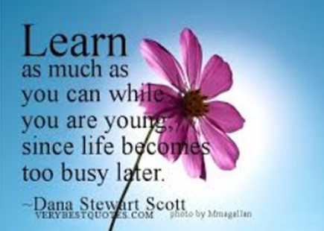

Holidays are always a welcome break from the normal routine and we all look forward to them. It gives us the opportunity to pursue all those activities that we enjoy but never found enough time to indulge in. So encourage yourself to take up a hobby, a sport or learn an instrument in these vacations. Urge yourself to read as “Books are our Best Friends”. Take membership of a library so that youlearns to enjoy the company of good books.
Another important aspect of a child’s overall development is directly related to the values that he/she embodies. No education can be complete without inculcating values. In today’s materialistic world value system seems to have been relegated to the background. Therefore, we would like to encourage you to spend time with your grand parents/ relatives during these holidays to bring clarity on moral and ethical values
Holiday homework has been designed in such a way that the students will get a chance to inculcate reading habit as well as engage themselves in meaningful pursuits that will enhance their comprehension and reasoning skills along with honing their aesthetic sense.
We wish you a very happy and a fruitful family time during this vacation.

Holiday Homework
Science Stream

- Based on the topics listed below, holiday homework in different subjects has been given to you as subtopics. Perform the task on the topic given. Also give your own imaginative ideas to make a model on them.
- List of Topics :
  - Cancer : types , cause, mode of spread, Detection and treatment . Specific reference material on alternative system of medicines like Ayurveda and naturopathy.
  - Heart Diseases: Blockages and their types, reasons, Diagnostic methods, Method of treatment( Angioplasty ( Stent types), Open Heart Surgery) , Prevention of silent heart attacks.
  - Vitamins : Natural and Synthetic, Classes of vitamins, Tests for vitamins, Vitamins related Diseases, negative impact of Synthetics vitamins on health.
  - Drugs : Types or classes, Structure, Extraction and usage method, Effect on body, Drug abuse in students reasons and prevention
  - Life style borne diseases: Obesity and obesogens , Eating disorders in teenagers: Anorexia, Bulimia nervosa , Binge eating, Pica,
  - Antibiotics : Types, mode of action on body , Why should not be consumed much, how are they prepared commercially, how to identify antibiotic as genuine or fake , (Mobile app),
  - Blood group and health : is there a link ? Genetic and autosomal blood group related diseases
  - Mental health : Coping with depression
Maths :
- Compare the cancer prevalence in different states of India minimum for four years (2011- 2014) using available data on internet. Represent the same in a graphical form. Also do the same for a time period of one year for five metropolitan cities of India.
- Compare the year wise total cancer prevalence in India (males and females, separate and then total) from year 2006 to year 2015. Represent the same in graphical form. Form a regression equation between male and females cancer patients.
- Cardiac Assist devices market is growing. Prove the statement by analysing the data available on net for at least two years. Analyse the growth in market by representing data in a graphical form.
English :

- Debate :Commercialisation in health industry is affecting the patients with limited means.
- Article writing: Dangers of drug abuse among youth.
- Speech :Allopathy has lost its sheen in current years. Ayurveda and naturopathy have emerged out to be its better alternatives.
Chemistry:

- Chemotherapeutic drugs in treating cancer: Composition and dosage
- Drugs in treating heart diseases: Chemical composition and role.
- Vitamins : Chemical Structure , Testing Vitamin C in a given sample
- Chemical structure of different drugs (Opoids, Cannabinoids, Coca Alkaloids)
- Chemistry behind blood groups : Surface sugars on RBC
Physics:

- Cancer Detection by instruments : MRI Imaging , CT Scan , Radiography, X- ray imaging
- Electrocardiography: Measuring heart activity (Electrical activity) to analyse its functioning.
- Bioreactors: Principle of working for antibiotics production on mass scale.
- Angioplasty: Specific reference to shape of catheter, stent, inflating of balloon to place stent in blocked artery.
Biology :

- Cancer : Cause and spread in body ( Primary and secondary tumours, Malignancy ), functions of normal body organs suppressed.
- Heart diseases: Blockages in cardiac artery and the reasons ( Specific reference to LDL and HDL), Protocol of open heart surgery
- Vitamins : Essentiality for normal body growth, Deficiency diseases
- Antibiotics : Mode of action of antibiotics, Antibiotic resistance
- Blood groups : testing surface antigens in blood vis a vis finding blood group

Commerce stream
Project-E COMMERCE
- This topic is classified into three groups
- Banking and finance
- Consumer goods
- Transport and communication
- All the students of class XI and XII have been divided into three groups.
- All the students from each group will collect related data and materials from different sources and will submit to the head of the project.
- On the basis of the collected information we will show how does the particular institution like amazon, uber, ola operate and the contribution of the electronics in their projects.
- Like we will display the live working models of the following projects.

- Students entitled for preparing e-commerce project They will prepare the following questions

- Banking and insurance sector

- What were the traditional methods of borrowing and lending?
- What were their drawbacks?
- What are the present systems of banking?
- What are their advantages and disadvantages?
- What could be the new system of banking and how will they remove the current disadvantages of the present system?
- Collect raw documents from different sources and prepare a p.p.t with animation?

- Consumer sector
- What was the traditional methods of marketing in India?
- What were its drawbacks?
- What are the modern system of marketing?
- How the new system overcoming the traditional drawback?
- What could be the future system of marketing?
- Transport and communication
- What was the traditional method of transportation in India?
- What were its drawbacks?
- What are the modern system of transportation?
- How the new system overcoming the traditional drawbacks?
- What could be the future system of transportation?

humanities stream
Making of Indian Constitution | Saloni Manisha
Meaning, necesity and Importance | anshu ,Ishita
difference B/w Rights nad Bill of rights and duties | Divya, Niharika
Fundamental Rights | Raghav Nitin
Equality | shruti , Vishakha
Freedom | Kadambari, deepa
exploitation | Prashant, Aryan
Religion | Madhavan Aarnav
cultural Education right | Aanchal anushka
constitutional remedies | tanvi ,deepanshu
writs in constitution | raghav nitin
Property | kadambari , deepa

ENGLISH

Question 1. Write a composition (in about 400-450 words) on any one of the following subjects:
(a)William Shakespeare says, ‘Defer no time; delays have dangerous ends.’ Give your views on the statement.
(b)Attitudes
Question 2 (a)Write a review (in approximately 300 words) of a book which has become a bestseller. Base your review on the hints given below:
Name of the book-author’s name-genre of the book (novel, storybook, poetry)-brief description of the content of the book-specific features of the book-reasons for its becoming a bestseller-overall impression.
(You may also include other relevant details.)
(b)Many trained engineers, doctors, scientists and IT professionals migrate to developed countries for better prospects. Write a proposal giving measures to check this brain drain from India.
Question 3. Design a poster providing all the information about a ‘Marathon’ being organized by your school in collaboration with Radio FM – 94.0.
Question 4 .Consult the dictionary for the following words and use them in at least two sentences of your own:
Kaput, quaff, sardonic, , blandishment, jamboree, cavalcade, awry, egregious, gregarious, legatee, confabulations, ken, incognito, fulminating, detente, penurious, demagogue, emulate, turgid.

Note: Read newspaper daily to keep yourself abreast of current affairs and work actively on enhancing your vocabulary. All the questions to be done in the fair Grammar/Writing Skills register.

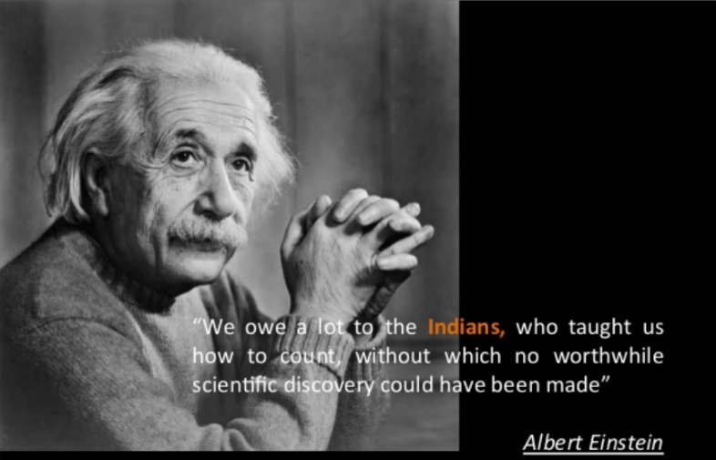

PHYSICS
WORK SHEET
Q1What is retardation and instantaneous acceleration of a body.
Q2 Describe in each case whether the motion is one two or three dimensional
- A moving car on a straight highway
- A piece of paper flying in air
- A ant crawling on a large sphere
- The earth revolving around the sun
Q3 Define :-
- relative velocity
- average velocity
- instantaneous velocity
Q4 Can an object be accelerated without speeding up or slowing down ? Explain.
Q5 Can speed of a body change if its velocity is constant?
Q6 Is it possible that velocity of an object be in a direction other than the direction of acceleration.
Q7 If instantaneous velocity of a particle is zero, will its instantaneous acceleration be necessarily be zero.

Q8 Explain ,when can an object in motion be considered as a point object.

Q9 Draw position time graph (x-t) graph of
- position acceleration
- negative acceleration
- zero acceleration
Q10 What is acceleration of a particle if position of a particle at any instant of time t is given by x=t³ .
Q11 A stone is dropped from top of the tower 50m high, simultaneously another stone is thrown upward with a speed of 20m/s. Calculate the time at which both the stone cross each other.
Q12 A car travels at a rate of 30km/h for 5 min and then 40km/h for 10 min find
- the total distance traveled by the car
- average speed of the car
Q13 A train is moving with the speed of 40km/h o the parallel track in the same direction what is the velocity of A train relative to B train and velocity of B train relative to A train.
Q14 Brakes are applied to a car traveling at 30m/s its velocity is reduced to 20m/s in 5 second calculate the retardation applied by the brakes also find the distance covered in 5seconds
Q15 The velocity time graph of a particle moving in a straight line is shown in figure . Find the distance traveled by the particle in timeperiod of t=0 and t=10s
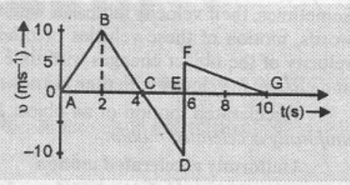
Q16 A car covers 1/3 part of the total distance with the speed of 20km/h and the remaining distance with the speed of 44km/h .Find the average speed of the car.
Q17 Find the ratio of the distances traveled by a freely falling body in first second and third seconds of its fall.
Q18 The displacement of a particle starting from rest (t=0) is given by x=6 t² - t³ . Calculate the time at which the particle will attain the zero velocity again.
Q19 A particle is located at x =0, t =0 starts moving along positive x direction with the velocity v that varies as v=( x )^{1/2} .How does the displacement of the particle vary with time.
Q20 Derive all three equations of motion for uniformly accelerated motion along the straight line by
(a)graphical method
(b)calculus method

COMPUTER SCIENCE/INFORMATIC PRACTICES
- Write programs in Python for the following:
- Calculate Total, Average and grade of a student on the basis of marks entered in 5 subjects.
- Swapping of two numbers using third variable
- Swapping of two numbers without using third variable
- Calculate Simple Interest and Compound interest.
- Area of a triangle.
- Area of circle.
- Check whether the number is positive or negative.
- Check whether the number is odd or even.
- Greater number among three numbers.
- Conversion from Celsius to Fahrenheit.
- Accept number of days and convert into Years weeks and days.
- Accept number and find its first four multiples.
- To find sum, difference, product, division and remainder of two numbers.
- To find cube and square of a number.
15. Prepare a power point presentation on cybercrime and the cyber security policies.

CHEMISTRY
Prepare your project Report according to your project heading project should cover these headings
1 HEADING
2 CERTIFICATE
3 ACKNOWLEDGEMENT
4 INDEX
5 INTRODUCTION
6 EXPERIMENT ( OBSERVATION TABLE , PROCESS, USES )
7 RESULT
8 CONCLUSION
9 BIBLOGRAPHY
Write or make 500 chemical formula from the given listofcationsandanions and learn them.
CATION | SYMBOL | ANION | SYMBOL
SODIUM | Na⁺ | CARBONATE | CO₃⁻²
POTASSIUM | K⁺ | BICARBONATE | HCO₃⁻²
LITHIUM | Li⁺ | SULPHATE | SO₄^{– 2}
SILVER | Ag⁺ | SULPHIDE | S ^{– 2}
MERCUROUS | Hg⁺ | SULPHITE | SO₃^{– 2}
CUPROUS | Cu⁺ | BISULPHATE | HSO₄ ^{– 2}
AMMONIUM | NH₄⁺ | BISULPHITE | HSO₃^{– 2}
MERCURIC | Hg⁺² | ACETATE | CH₃COO –
LEAD | Pb⁺² | CHLORIDE | Cl–
CADMIUM | Cd⁺² | BROMIDE | Br –
ARSENIC | As⁺³ | IODIDE | I–
ALUMINIUM | Al⁺³ | HYDROXIDE | OH–
FERROUS | Fe⁺² | PHOSPHATE | PO₄^{–3}
FERRIC | Fe⁺³ | BORATE | BO₃–
CUPRIC | Cu⁺² | NITRATE | NO₃–
CHROMIUM | Cr⁺³ | NITRITE | NO₂ –
ZINC | Zn ⁺² | NITRIDE | N ^{–3}
MANGANESE | Mn⁺² | CHLORATE | ClO₃–
NICKEL | Ni⁺² | PERCHLORATE | HClO₃–
BARRIUM | Ba ⁺² | SILICATE | SiO₃^{– 2}
STRONTIUM | Sr⁺² | FLUORIDE | F –
CALCIUM | Ca⁺²
MAGNESIUM | Mg ⁺²
BISMUTH | Bi ⁺²
STANNOUS | Sn⁺²

BIOLOGY
A: Using study material provided , answer the questions that are there given after it as short question bank.
CHAPTER 8 : CELL STRUCTURE AND FUNCTION
- Study of form, structure, and composition of cell is called cytology.
- Cell is the structural and functional unit of life. In unicellular organism (amoeba, paramecium, yeast, bacteria) single cell performs all the essential functions of life.
- In multicellular organism, different kinds of tissues perform different function and have division of labour.
- Anton Von Leeuwenhoek first saw and described a live cell. Robert Brown later discovered the nucleus.
- MetthiasSchleiden and Theodore Schwann( 1938) proposed the cell theory which was later modified by Rudolf Virchow(1855)-
- All living organisms are composed of cells and products of cells.
- All cells arise from pre-existing cells.
Prokaryotic cells | Eukaryotic cells
- Membrane bound nucleus is absent.  - Cells are smaller in size.  - Single chromosome is present.  - Membrane bound organelles are absent. | - Membrane bound nucleus is present.  - Cells are larger in size.  - More than one chromosome is present.  - Membrane bound organelles are present.
Shape and size of cells varies greatly according to their position and function. Mycoplasma is the smallest cell and largest isolated cell is the ostrich egg. The shape of cell may be cuboid, columnar, polygonal, thread like or irregular.
Prokaryotic Cells
- Prokaryotic cells are represented by Bacteria, Blue green algae, Mycoplasma and PPLO. They multiply rapidly and vary in size greatly.
- Bacterial cells may be Bacillus (rod shaped), Coccus (spherical), Vibrio (comma-shaped) and Spirillum (spiral).
- All prokaryotic cells have cell wall surrounding the cell membrane except in Mycoplasma. Genetic material is naked.
- The plasmid DNA, in some bacteria provides some special features like resistance to antibiotics.
- Cell organelles like Mitochondria, Golgi bodies etc. are absent in prokaryotes. A specialized differentiated cell membrane called Mesosome is the characteristic of prokaryotes.
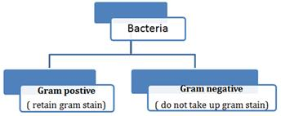
- In bacterial cell a chemically complex cell envelope is present, which consist of three layers. The outermost is Glycocalyx, middle one cell wall and inner innermost is the cell membrane.
- Glycocalyax may be as loose sheath in some bacteria called slime layer. In some other bacteria Glycocalyx may be thick and tough called capsule.
- Plasma membrane is semi-permeable having mesosome in the form of vesicles, tubules and lamellae. They help in cell wall formation, DNA replication and distribution to daughter cells.
- Motile bacterial cell contain flagella, which is composed of filament, hook and basal body. Pili and fimbriae are the other surface structures that help the bacteria to attach with host and other substances.
- In prokaryotes, ribosome are attached with cell membrane having two sub-units – 50S and 30S to form together 70S prokaryotic ribosomes.
- Ribosomes are site of protein synthesis. Ribosomes attached with mRNA to form a chain are called polyribosomes.
- Reserved materials in prokaryotic cells are present in cytoplasm as cell inclusion bodies, which may contain phosphate, granules, glycogen granules etc.
- Gas vacuoles are found in blue green algae and purple and green photosynthetic bacteria.Store gases, provide buoyancy, mechanical strength.
Eukaryotic Cell
- Eukaryotic cells are present in Protista, plants, Animals and Fungi. Cytoplasm is divided into compartments due to presence of membrane bounded organelles.
- The cells contain well organized nucleus with nuclear membrane. The genetic materials are arranged in chromosomes.
- Plants cells differ in having cell wall, plastids and large central vacuole as compared to animal cells. Animal cells have centrioles, which are absent in plant cells.
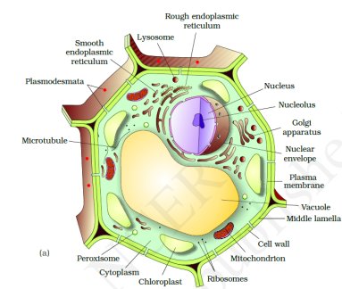
Plant cell

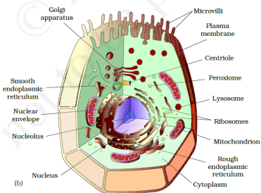
Animal cell
- Cell membrane is composed of lipids that are arranged in bilayer. The lipid component is mainly composed of phosphoglycerides. Later it was found that protein is also present in cell membrane. Ratio of protein and lipids varies in different cells.
- Membrane protein may be integral or peripheral. Integral protein remains buried in membrane but peripheral protein lies on the surface.
- Singer and Nicholson (1972) proposed fluid mosaic model. According to this model the quasi-fluid nature of lipid enables lateral movement of protein within the bilayer of lipids.
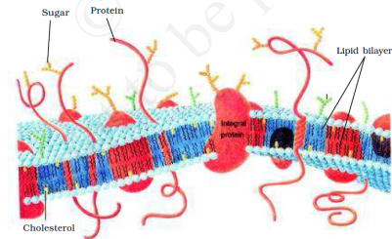
- The main function of plasma membrane is the transport of molecules across it.
Active Transport | Passive Transport
- The transport involves an expenditure of energy by the cells.  - It occurs against the concentration gradient.  - It is a rapid process. | - The cells do not spend energy in passive transport.  - This transport is always along the concentration gradient.  - It is comparatively slow process.
- The movement of water from higher concentration to lower concentration by diffusion is called osmosis.
- Cell wall is present in plant cells and fungi. Algae have cell wall made up of cellulose, galactans and minerals like calcium carbonate. In other plants it consists of cellulose, hemicellulose, pectin and proteins.
- Primary cell wall of young plant is capable of growth, which diminish in mature cells. Secondary cell wall is formed on inner side of the cells.
- Plasmodesmata connects the cytoplasm of neighboring cells.
- Endomembrane system of cell includes endoplasmic reticulum, golgi complex, lysosomes and vacuoles.
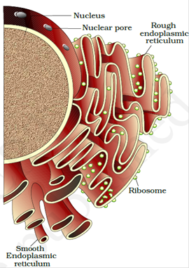
- Endoplasmic Reticulum are the tubular structure scattered in the cytoplasm.
- Rough endoplasmic reticulum bears ribosomes on its surface. RER is involved in protein synthesis and secretion.
- Smooth endoplasmic reticulum does not bear ribosomes on its surface. SER is involved in lipid synthesis and steroidal hormones.
- Golgi apparatus was first observed by Camillo Golgi in 1898 near nucleus. They consist of many flat, disc-shaped sacs or cisternae stacked parallel to each other.
- Golgi apparatus performs the function of packaging of materials and its transportation. A number of protein synthesized by ribosomes are modified in cisternae of golgi apparatus. Golgi apparatus is the site for synthesis of Glycoprotiens and glycolipids.
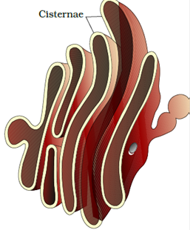
- Lysosomes are membrane bound vesicular structures formed by the process of packaging in the Golgi apparatus. They are rich in hydrolytic enzymes- lipase, protease, carbohydrases active at acidic PH. These enzymes are capable of digesting carbohydrates, proteins, lipids and nucleic acids.
- Vacuoles are membrane bound space found in cytoplasm containing water, sap and excretory product. They are bound by single membrane. They form contractile vacuole and food vacuole in many organisms.
- Mitochondria is double membrane bound structure with the outer membrane and inner membrane dividing its lumen in two compartments. The inner membrane forms a number of infoldings called cristae towards the matrix.
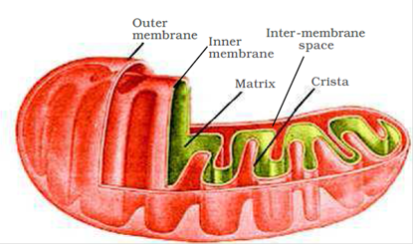
- Two membranes have their own specific enzyme.
- Mitochondria are sites for aerobic respiration. They produce cellular energy in form of ATP so, they are called power house of the cells. The matrix of mitochondria also contain circular DNA molecules, a few RNA molecules, ribosomes and components of protein synthesis.
- Plastids are found in plant cells and in Euglenoids.
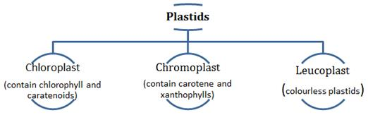
- Chloroplast contains chlorophyll that traps solar energy for photosynthesis. Chromoplast provides yellow, orange and red colours to different parts of plants.
- Leucoplasts are colourless plastids that store food, amyloplasts (carbohydrates), elaioplasts (oils) and aleuroplasts (proteins).
- Chloroplasts are double membrane structures. The space limited by inner membrane is called stroma. Thylakoids are present in stroma as stacks like the piles of coins called grana.
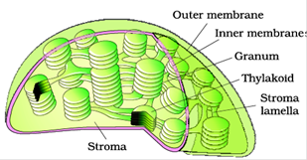
- Stroma contain enzymes for synthesis of protein and carbohydrates. Double strand circular DNA and ribosomes are also present in stroma.
- Eukaryotic cells have 80S ribosomes. They have granuler structure with two subunits.
- Centrosome is an organelles containing two cylindrical structures called centrioles. Each centrioles is made up of 9 fibrils of tubulin protein. Central part of centriole is called hub and it has 9 radial spokes and 9 triplet fibrils on periphery..Thus centriole appears like a cartwheel in T.S.
- Nucleus has highly extended, elaborate nucleoprotein fibres called chromatin, nuclear matrix and nucleoli. The outer membrane is continuous with endoplasmic reticulum and bears ribosomes.
- The chromatin materials change into chromosome during active cell division. It consists of DNA and histone proteins.
- Every chromosome has a primary constriction or the centromere, on the sides of which disc shaped kinetochores are present.
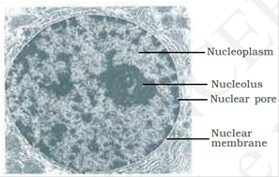
- On the basis of position of centromere chromosomes are of following types-
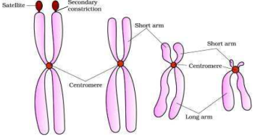
Metacentric Sub-metacentric Acrocentric Telocentric
Some chromosomes have non-staining secondary constriction at certain location. This gives a small fragment called satellite.

VSA Questions:
- Name two cell organelles that are bound by two membranes.
- Name one cell organelle that has microtubules with protein tubulin.
- How is a 70 S ribosome different from 80-S ribosome?
- Name the cell organelle that has ribosomes on its surface. Also give its function.
- Define plasmodesmata.
- Golgi bodies and mitochondria are referred as semi-autonomous organelles.Why?
- Name any two enzymes that Lysosome contains. Also name the organelle that forms enzymes present in lysosomes.
- Multicellular organisms have division of labour. How?
- What are gas vacuoles? State their function.
- Give the two salient features of cell theory.
- What is a polysome? Give its function.
- What do elaioplasts and aleuroplastsstore ?
- What is the composition of plasma membrane of human erythrocyte.
- List two functions of mesosome.
- What is satellite DNA? Mention its significance.
SA Questions:
1. (a) Give the characteristic features of the genetic material of bacteria.
(b) What is plasmid ? What is its importance ?
2. Diagrammatically represent the types of chromosomes based on the po
sition of centromere.
- Comment on the cartwheel structure of centriole.
- Differntiate between RER and SER.
- Give the biochemical composition of plasma membrane. How are lipid molecules arranged in this membrane?
- Give two differences between a prokaryotic and eukaryotic cell.
- What are nuclear pores? State their function.
- Both Lysosomes and vacuoles are endomembrane structures, yet they differ in terms of their functions. Comment.
- Write a short note on primary cell wall.
- What are cell inculsions in a prokaryotic cell?
- Give the specific scientific terms for the following:
  - Cluster of ribosomes found in the cytoplasm
  - Extensive infoldings of the inner membrane of mitochondria.
  - Stacks of closely packed thylakoids
  - Stalked particles on the inner membrane of mitochondria
  - Single membrane that covers vacuole
- Distuinguish between chromatin and chromosome.
- Microtubules are different from microfilaments.Justify.
- How does a mitochondrion differs functionally from a chloroplast?
LA Questions
- Describe the structure of a ribosome.
- Draw a labelled diagram of prokaryotic cell.
- Give the difference between cell walls of gram positive and gram negative bacteria.
- Describe the structure and function of :
    - Mitochondria (ii) Chloroplast (iii) Golgi body
- Write an account of lysosomes and their role in cellular metabolism.
- Give two points of difference between active transport and passive transport.

VLA Questions :

- Describe in detail the Fluid Mosaic Model of Plasma membrane as proposed by Singer and Nicholson in 1972.
- (a) Diagrammatically represent the types of chromosomes based on the position of centromere.
(b) What does chromatin contain ?
(c) What is perinuclearspace ?
3. Describe the structure of nucleus in detail.

Holiday Homework :
- Collect the information on any two topics, of the topics given below. Also give your own imaginative ideas to make a model on them.
- List of Topics :
  - Cancer : types , cause, mode of spread, Detection and treatment . Specific reference material on alternative system of medicines like Ayurveda and naturopathy.
  - Heart Diseases: Blockages and their types, reasons, Diagnostic methods, Method of treatment( Angioplasty ( Shunt types), Open Heart Surgery) , Prevention f silent heart attacks.
  - Malaria : Disease cycle in Female Anopheles and then in man, Symptoms, Treatment and prevention.
  - Vitamins : Natural and Synthetic, Classes of vitamins, Tests for vitamins, Vitamins related Diseases, negative impact of Synthetics vitamins on health.
  - Drugs : Types or classes, Structure, Extraction and usage method, Effect on body, Drug abuse in students reasons and prevention
  - Life style borne diseases: Obesity and obesogens , Eating disorders in teenagers: Anorexia, Bulimia nervosa , Binge eating, Pica,
  - Antibiotics : Types, mode of action on body , Why should not be consumed much, how are they prepared commercially, how to identify antibiotic as genuine or fake , (Mobile app),
  - Blood group and health : is there a link ? , Genetic and autosomal blood group related diseases

MATHEMATICS

Worksheet
Topic: Chapter 3 (Trigonometry)
For 1 mark
- Evaluate $\tan{\frac{13π}{4}}$
- Evaluate $\sin{\frac{17π}{4}}$
- Evaluate $\cos{(-{1710}^{0})}$
- Evaluate $\operatorname{cosec}{(-{7π}/4)}$
- $Findthevalueof\frac{2tan{15}^{0}}{1+\tan^{2}{{15}^{0}}}$
- $Find\operatorname{cosec}\left(\frac{x}{2}\right)ifcosx=\frac{-12}{13}andxliesin 3rdquadrant.$
- Find $\cot\left(-\frac{21Π}{4}\right).$
- Find the value of $\operatorname{cosec}{(-\frac{11π}{3})}$
- If $\cot{x}$= $-\frac{12}{5}$, x lies in 2nd quadrant then find $\sin{x}$ .
- Find the principal solution(s) of $\tan{x}$ =$\frac{-1}{\sqrt{3}}$
For 4 marks
- Prove that $\frac{\cos{4x+\cos{3x+\cos{2x}}}}{\sin{4x+\sin{3x+\sin{2x}}}}=\cot{3x}$
- $Provethattan4x= \frac{4tanx(1-\tan^{2}{x)}}{1-6\tan^{2}{x}+\tan^{4}{x}}$.
- Prove that $\frac{(sin{7x +\sin{5x) + (\sin{9x + \sin{3x}})}}}{\left(\cos{7x +}\cos{5x}\right) + (\cos{9x + \cos{3x}})}$ =$\tan{6x}$
- $\frac{sin3Acos4A-sinAcos2A}{sin4AsinA+cos6AcosA}=tan2A$

- P$rovethat\frac{sin5x-2sin3x+sinx}{cos5x-cosx}$ =tanx
- Find the value of $tan⁡(\frac{π}{8})$
- $Find\sin\left(\frac{x}{2}\right), cos\left(\frac{x}{2}\right)andtan\left(\frac{x}{2}\right)ifcotx= -\frac{3}{4}, xin 2ndqudrant.$
- $Solvefor x :2\cos^{2}{x+3sinx=0.}$
- Solve for $x : \sin{2x}-\sin{4x}+ \sin{6x=0}$
- Solve for θthe equation cosθ+ cos3θ- 2cos2θ=0.
- Solve for $x$2$\cos^{2}{x}+ 3\sin{x=0}$
- $Solve\sqrt{3}cosx+sinx$=$\sqrt{2}$
- $Solvesin2x+sin4x+sin6x=0$
- $Findthegeneralsolution\cot^{2}{x+\frac{3}{sinx}}+3=0$
- $Solve : cosecx=cotx+ \sqrt{3}$
- Prove that sin20ºsin40ºsin60ºsin80º=3/16.
- $Provethatsin{10}^{0}sin{30}^{0}sin{50}^{0}sin{70}^{0}=\frac{1}{16}.$
- $Provethatcos{20}^{0}cos{30}^{0}cos{40}^{0}cos{80}^{0}=\frac{√3 }{16}$
- Prove that $cos{12}^{0}cos{24}^{0}cos{48}^{0}cos{96}^{0}=-\frac{1}{16}$
- $Provethatcos{20}^{0}cos{40}^{0}cos60^{0}cos80^{0}=\frac{1}{16}.$
- $Provethattan{20}^{0}tan{40}^{0}tan60^{0}tan80^{0}=3$
- $Provethatsin{18}^{0}=\frac{\sqrt{5}-1}{4}.$
- $Provethatcot7{\frac{1}{2}}^{0}=\sqrt{2}+\sqrt{3}+\sqrt{4}+\sqrt{6}$
- Pr$ovethat 2cos =\sqrt{2+\sqrt{2+\sqrt{2+2cos8}}}$
- Prove that $tan3xtan2xtax=tan3x-tan2x-tanx$
- Prove that$cot3x.cot2x-cot3x.cot5x-cot5x.cot2x=1.$
- $Provethatcotxcot2x-cot2xcot3x-cot3xcotx=1$
- $Provethatsinx+sin3x+sin5x+sin7x=4cosxcos2xsin4x$
- $\frac{1}{sin{10}^{0}}-\frac{\sqrt{3}}{cso{10}^{0}}=4$
- $Prove\frac{\sin\left(B-C\right)}{sin⁡(B+C)}=\frac{b^{2}-c^{2}}{a^{2}}$
For 6 marks
- Prove that:
- Prove that:
- $Provethatsinx+sin2x+sin4x+sin5x=4\cos\left(\frac{x}{2}\right)\cos\left(\frac{3x}{2}\right)sin3x$
- $Evaluatesin{36}^{0}.$
- $Provethat\cos^{2}{x+\cos^{2}{(x+\frac{2π}{3})}}+\cos^{2}{(x-\frac{2π}{3})}=\frac{3}{2}$
- $Evaluate\cos^{3}{x+\cos^{3}{(x+\frac{π}{3})}}+\cos^{3}{(x-\frac{π}{3})}$
- If tan($\frac{π}{4}+\frac{θ}{2}$)=tan³($\frac{π}{4}+\frac{α}{2}$), prove that $sinθ=\frac{3sinα+\sin^{3}{α}}{1+3\sin^{2}{α}}$

BUSINESS STUDIES
(Any three of the following may be done)
1. Visit a nearby bank and observe their way of working. How many counters are there, what work each counter perform note it down . Try to speak to the manager and enquire about the different functions that their bank performs, about schemes and programmes also.
2. Prepare a neat and impressive Chart on the following topic: Students from Roll Nos.
1 to 15 - Logos of different Companies
16 to 30 - Taglines of different Companies
31 to 45 - Auxiliaries to Trade
3. Visit website of a company doing business through internet (for example: ebay,etc.). Study the products/services offered by the company, mode of payment, choice available to customers, method of delivery of products, details of the product available on website, any special offers or discounts available, etc. prepare a report.
4. Visit a departmental store and pick up five products manufactured by multinational corporations. Prepare a brief profile of the concerned multinational corporations.
5. Make a project on Fast moving consumer goods
6. Visit a local business enterprise and identify its nature of business activity. Find out the obstacles faced by it and the steps taken to encounter them.
7. Select any co-operative society or Joint Stock Company and analyze the following aspects
a) Objective of formation
b) Nature and size of business
c) Number of members and their roles
d) Control and management of company/ co-operative society.
e) Investment made in the business enterprise.
Instructions :
(a) Project must be including Cover Page, Page of contents
(b) Project should have 25-30 pages and it should be handwritten

ACCOUNTANCY
- Visit a bank and do a survey of their books of accounts specially the type of work they are involved in and draft a report on the same.
(a) Explain the accounting cycle.
(b) Explain different types of accounting.
(c) Explain qualitative characteristics of accounting information.
2. State, giving reasons, whether the following are transactions or not:
- Purchased machinery worth 70,000.
- Appointed Sandeep as accountant
- Furniture has been depreciated by 1,000
- Paid rent 6,000.
- Rent paid for the next year 10,000.
- Decided to purchase shares of ITC Ltd.
- Sold old newspapaers for 200.
- Sold a machinery for 4,000 on credit to Sri Raja Roy.
- Goods lost by fire 10,000.
- Submitted a tender for a work 10,000.
- Received an order for supply of goods to Roy & co. 25,000.
- Took a loan from Swapan 10,000.
- Deposited cash into bank 2,000.
- Supplied goods to bros. 5,000 as per their order.
- Distributed free samples 4,000.
- Received free samples 2,000.
- Appointed Subhash as manager.
- Sent a fax message to a supplier.

- Prepare accounting equation from the following transactions:
- Azhar started business with cash 70,000 and plant 30,000.
- Purchased goods for cash 20,000.
- Sold 1/3rd of the goods sold at a profit of 50% to Bikram and another 1/3rd for cash at a profit of 40%.
- Sold plant costing 2,000 for 2,500.
- Paid insurance 1,000 (half of its relates to current year and remaining half for the next year)
- Purchased goods valuing 20,000 for 18,000.
- Sold goods costing 15,000 for 27,000
- Paid salary to the accountant Charandas 6,000.
- Rent due but not paid 3,000.
- Commission due from Dilip Bros. 8,000 but not yet received.
- Took a loan of 10,000 from Durga.
- Gave a loan of 15,000 to Bhawani.
- Purchased an old scooter from Biswanath for 18,000 and sold it to Rani for 20,000.
- Plant depreciated by 1,000.
- Withdrew goods costing 1,000 for personal use.
4. Show the accounting equation on the basis of the following information
- Shri Ganesh commenced business with cash 35000, goods 8000 and furniture 7000.
- Bought furniture from M/s Mohan furniture’s on credit for 3000.
- Purchased goods from sohan for cash 35000.
- Sold goods to shyam for cash 40,000 (costing 30,000).
- Bought goods from Ramesh for 30,000.
- Sold goods to shyam costing 30,000 for 50,000.
- Received 49,500 from shyam in full settlement.
- Paid 29,700 to Ramesh in full settlement.
- Paid half the amount owed to M/s Mohan.
- Withdrew 1000 for personal use.
- Withdrew goods for personal use (cost 500,sale price 600).
- Purchased household goods for.15000 giving 5000 in cash and the balance through a loan.
(m) Paid cash 500 for loan and 300 for interest.
(n) Goods destroyed by fire (cost. 500,sale price 600).
(o) Paid salary 500 and salary outstanding 100.
(p) paid rent in advance 2000.
(q) Accrued interest 500.
(r) Commission received in advance 1000.
(s) Charged depreciation of 400 on furniture.

(The work may be done in the question bank register)

ECONOMICS
Q1. Define opportunity cost.
Q2. Write 3 differences between positive economics and normative economics.
Q3. Explain meaning of MOC with example.
Q4. What are the central problems and why do they arise?
Q5. Explain central problem how to produce with an example.
Q6. With an imaginary schedule draw PPC which is based on constant MOCxy and show the following points:
- Loss in production due to recession
- Make in India
- Demonetisation
- Resources of X is increasing and at the same time resources of Y is decreasing

Q7. Write 4 assumptions of PPC.
Q8. How is the central problem what to produce explained with the help of PPC?
Q9. Explain law of diminishing marginal utility.
Q10. With the help of schedule and diagram show the relationship between TU and MU.
Q11. Define statistics in singular sense.
Q12. What are the 5 stages of statistics?
Q13. Define statistics in plural sense.
Q14. Why is PPC downwards sloping and concave to the origin?
Q15. Explain the importance of statistics in economics.
Q16. What are the features of statistics?
Q17. What are the limitations of statistics? Explain briefly.
Q18. Explain 2 importance and 2 limitations of statistics in economics
Q19. Define 3 features of capitalist, socialist and mixed economy.
Q20. Write the difference between between microeconomics and macroeconomics (at least 6 points).

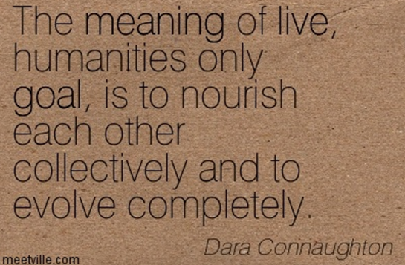

GEOGRAPHY
Do any one of the following:
I. Make a PowerPoint presentation of about 15-20 slides on origin of the earth under the following points:
* Information about the hypotheses given by different geographers.
* The Big Bang theory and the result of explosion in the nebula.
* Formation of the Earth.
(Submit a hard copy of the presentation in a folder.)

II. Collect information about the earthquakes which have occurred around the world in the year 2012 and compile the information in the form of a report. Also, find out if the earthquakes occurred during the mentioned period have any similarity in terms of area where they have occurred. Analyse the possibility of their occurrence in future along with their effects.
(To be done on A4 size sheets.)

III. Collect information about the project ‘Stardust’ (Website: www.sci.edu/public.html and www.nasm.edu) along the following lines.
* Which is the agency that has launched this project?
* Why are the scientists interested in collecting Stardust?
* Where from the Stardust is being collected?
(To be done on A4 size sheets.)

FINE ARTS

1.Visit museum and Art galleries and make report.
2.Collect reproduction of old masters (artist) and copy any one in A4 size sheet with colour.
3.Gain knowledge of art materials available in the market.
4.Study and make notes of terminologies-----perspective, eye level ,fixed point of view, vanishing point, ratio-proporation, sketching ,drawing light & shade, land scape, vertical, horizontal, two & three dimensional, transparent & opaque colour.
5.Draw four imaginative painting based on subject from life and or nature in water colour( ½ sheet).
6.Draw two sketches daily in A4 size art file.
MASS MEDIA STUDIES
I. Write articles on the following topics
1 Electronic media is more powerful than print media
2 Print media has a social responsibility
3 Does media influence the culture
II. Collect information on culture nuances if people from different parts of world. Your information may be focused on
1 Greeting a stranger
2Going as a guest to a party
3 Saying goodbye
4 Expressing grieve over the death of a loved one
5 Participating in a formal interaction
III. Write a review on the latest electronic gadget in 200 words
IV. Write a newspaper article on some of the popular programs aired by akashwani. AIR since its inception . Your article can include writeup on some famous singer or musician who began their career in AIR.
POLITICAL SCIENCE

1. Write note on importance of Rights, citing examples from page no.27.
2. What would you order the government on the case given on page 33 ÿou are the Judge”.
3. View of SomnathLahiri on Fundamental Rights on page 36. Do you agree.
4. SardarHukam Singh views on Miniority Rights page no 40.
5. Write note on Right to Property.
6. Write Tajamal Hussain’s view on Separate electorate page no 63.
7. Read the cartoon given on page no 52, 61, 67 & 71 & explain them.
8. Write note on article 324(1) page no 68.
9. Explain the functions of the constitution.
10. Explain the factors responsible for making a constitution effective,

PSYCHOLOGY

Students to make a project file for the following given work.
- Conduct a Survey and meet five different people around you (non-relatives). Talk to them and try to note down their respective problems/issues in their life.

- Watch any movie from the following and make a project stating your observations about different characters in the movie and also write about the psychological disorder shown in the movie.

- Split (James McAvoy) on Dissociative Identity Disorder (DID)
- 15 Park Avenue (Aparna Sen) on Schizophrenia
- Maine Gandhi Ko Nahi Maara on Schizophrenia
- Beautiful Mind (2001) on Schizophrenia
- U Me Aur Hum on Alzheimer’s
- Sybil on Multiple Personality Disorder (MPI)
- Taare Zameen Par on Dyslexia (Learning Disorder)
Note- Creativity and dedication are important considerations
Make the projects in detail as it carries marks in assessment.

HINDI MUSIC (Vocal)

- Prepare project on noted Indian musician :-

- Pt.V.N.Bhatkande
- Pt.VishnuDigambarPaluskar

- Revise the work done before summer vacation.

- Listen to these raga and try to understand their structure with respect to the following :-

- Aroha ,Avaroha,Pakad ,Bandish of Raga(Chotakhyal)
- Bihag
- VrindavaniSarag
- Jaunpuri
- Bhairavi

PHYSICAL EDUCATION
OLYMPIC MOVEMENT
Very shot answer questions carrying 1 mark
- What is Olympic Movement?
- Explain about the symbol of Modern Olympic Games?
- Mention about Olympic Flame?
- What are Olympic Award?
- Write down the Olympic Oath?
- Mention the rules for competitors for Modern Olympic Games?
- What is Olympic Motto?
- What do you mean by CITIUS, ALTIUS and FORTIUS?
- What is the aim of CBSE sports?
- Describe the objectives of Dronachary Award?
- What is the criterion for Dronacharya Award?
- Who can participate in Paralympics games?
Short answer question carrying 3 marks
- Write a short note on the Olympic flag?
- Explain about international Olympic Committee.
- Discuss about closing ceremony of Modern Olympic Games?
- Explain the role played by Coubertin in the origin of Modern Olympic Games?
- Are the Olympic Games free from discrimination today? Give your views.
- Mention the rules for competitions in Ancient Olympic Games?
- Discuss about opening ceremony of Modern Olympic Games
- Elucidate the objectives of Modern Olympic Games?
- Discuss about the categories of disability for Paralympics Games?
- Discuss the general rules related to the organization of CBSE Sports competitions?
Long answer question carrying 5 marks
- Write down a detailed note on Ancient Olympic Games?
- Explain the origin of Modern Olympic Games.
- Elucidate in detail about International Olympic Committee.
- Write a note on Rajiv Gandhi KhelRatna Award?
- Write a note on Chacha Nehru Sports Award.
- Discuss about the Paralympics Movement in detail.
YOGA
Very short answer questions carrying 1 mark
- What is yoga?
- What is meditation?
- What do you mean by shatkarmas or yogic kriyas ?
- What is hypertension?
- What do you mean by diabetes?
- What do you mean by obesity ?

Short answer question carrying 3 marks
- What do mean by asanas? Discuss the types of asanas ?
- What do you mean by pranayama ? Mention the types of pranayama ?
- Discuss the measures to be taken to prevent hypertension?
- Explain any three elements of yoga.
- Explain the prevention and management of diabetes.
- “Yoga is an Indian Heritage “ elaborate this statement .
Long answer question carrying 5 marks
- What do you mean by yoga? Explain its importance in daily life.
- Discuss the elements of yoga.
- What do you mean by common lifestyle diseases? Discuss the prevention and management of hypertension.
- Discuss the prevention and management of obesity in detail.
- Give detailed notes on any two of the following :
  - Yogic kriyas
  - Prevention and management of back pain.
  - Asanas
PHYSICAL FITNESS, WELLNESS AND LIFESTYLE
Very shot answer questions carrying 1 mark
- What is the meaning of physical fitness?
- What do you mean by wellness?
- What is meant by lifestyle?
- Define Endurance?
- What do you mean by indicators of health?
Short answer question carrying 3 marks
- Elucidate the importance of physical fitness and wellness in brief.
- Define strength and discuss its types in brief
- What is flexibility? Discuss the various types of flexibility in brief.
- Briefly discuss about coordinative abilities?
- Discuss healthy diet as a component of positive lifestyle?
- Last year, our school organised a programme Run for Unity .All the students and teachers of our school were involved in this race. Such runs promote unity ,peace and harmony among the people .After covering a distance of two kilometers ,one student felt chest pain spontaneously .He complained to a teacher regarding pain .Immediately some of the teachers who were running beside him ,took him to the doctor for necessary check up. His blood pressure was measured and ECG was also performed .Doctor said that it was not the case of heart problem. It was surely the problem of second wind which is a usual phenomenon for individual who does not practice to run a race. Based on the above passage, answer the following questions (1x3=3)
1. What is the purpose of run for unity?
2. What values did the teachers show by taking the student to the doctor immediately?
3. Was the student enough physically fit?
Long answer question carrying 5 marks
- Enumerate the factors affecting physical fitness and wellness in detail.
- Define physical fitness and wellness .Elaborate the importance of physical fitness and wellness in detail.
- How can health threat be prevented through lifestyle change? Discuss in detail.

