PRAGATI PUBLIC SCHOOL
Session: 2018-19
CLASS : V

THEME:-CURRENCY AND BANKING SYSTEM
Dear Parent,
‘Exciting time is here again! Its time for Summer Vacation and fun filled activities’.
Children are reservoirs of potential which needs to be tapped and channelized in diverse ways. We feel that it is very important to fire their imagination and foster an outlook that helps them explore, discover and rediscover. Children should be encouraged to develop intellectually and physically. Summer Vacation is the best and fruitful time for learning and for nurturing creativity. It is the time when you can connect with your child in many ways. The Holiday Homework designed would not only enhance achievements of your children but also help to enhance family relationships. It would teach your child to work independently and would improve their basic academic skills, such as reading, writing, and spellings and would help them develop personal skills and time management. As parents, kindly motivate and lend support to your children and ensure that they complete the given work well-in-time and to the best of their ability. Your encouragement can actually make a huge difference to the ultimate learning outcome of these projects. We would be happy if parents encourage children to work on their own. A few suggestions that you should may keep in mind.
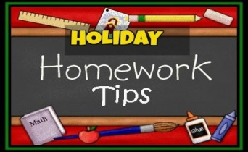
- Spend quality time with your children. Take them out to outings and have fun time together.
- Help your children to become independent by giving them responsibilities.Involve them in small household activities.
- Inculcate in them good manners, healthy habits and respect for elders.
- Converse with your children in English.
- Encourage your children to read books to enhance their language skills.Reading will also boost their interpretative skills and provide them valuable literary experience.
- Cultivate sportsmanship by encouraging your children to play various Indoor and Outdoor games. Remember that Summer Vacation is the time to relax and enjoy.
- Gently encourage your children to raise a kitchen garden by planying seeds.
- Keep your children away from TV,Mobile phones,computers,any other electronic gadgets,etc.
- Look into the eyes of your little one and Thank God for giving you one-wonderful gift.In a few years from now,they will be soaring into greater heights.
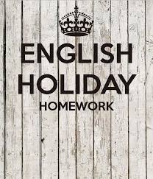
- Roll no. 1-11 :-
Make a flip magazine-
# The flip magazine should include the following points:-
# Introduction-Barter System
# Advantages and Disadvantages of Barter System .
# Use colourful pictures to elucidate your ideas.
# Do the work on A3 sheets.
Design a colourful advertisement of a bank on an A3 size sheet so that the people get to know about the features and facilities available in it.
- Roll no. 12-23:-
On the topic ‘Indian Rupee-Backbone of our country’ record your observation in a brochure form using A3 size coloured sheets.
Focus on any one aspect of currency-
# Design
# Value
# Material used
Make a collage of the Journey of Indian Currency since 1947 to the present on a chart paper.
- Roll no. 24-36:-
Make a project in the form of booklet with pictorial presentation based on
# Name of any three Magadha Rulers
# Changes brought in the currency
# What role did they play in Developing the currency.
Do picture composition.
# Draw a picture on an A3 size sheet depicting the ‘ Barter System’.
# Explain the picture in your own words.
Make a poster on Internet Banking or e-banking on an A3 size sheet.Use an appealing caption and a slogan along with colourful pictures.

fganh x`gdk;Z&
1& ,d pkVZ ij uhps fn, x, fdlh ,d fo’k; ij dfork fy[ksa&
1&IkSls dh vtc dgkuh& jksy uacj 1 ls 3
2& iSls dh lhek& jksy uacj 4 ls 6
3& uksVcanh & jksy uacj 7 ls 9

2& fdlh ,d fo’k; ij 250 “kCnksa esa fuca/k ,d jaxhu pkVZ ij fy[kdj yk,Wa&
1& #i, dh vkRedFkk& jksy uacj 10 ls 12
2& foeqnzhdj.k& jksy uacj 13 ls 15
3& dkyk /ku& jksy uacj 16 ls 18

3& uksVcanh& vFkZ] ykHk rFkk gkfu;kWa& jksy uacj 19 ls 21
4& fMftVy djalh ;k fMftVy eqnzk ds ckjs esa foLrkj ls crkrs gq, blds ykHk o gkfu;kWa ,d
pkVZ ij n”kkZ,WaA jksy uacj 22 ls 24
5& Hkkjrh; eqnzk ds ckjs esa dksbZ 20 jkspd tkudkjh ,d pkVZ ij fy[ksaA jksy uacj 25 ls 27
6& Hkkjrh; #i;ksa o flDdksa ds bfrgkl dks jkspd cukrs gq, QwVh dkSM+h ls vkuk rd Vscy
:i esa ,4 “khV ij n”kkZ,WaA jksy uacj 28 ls 30
7& vius ukuk&ukuh ] nknk&nknh ls iqjkus flDds ysdj bdV~Bk djsaA jksy uacj 29 ls 34

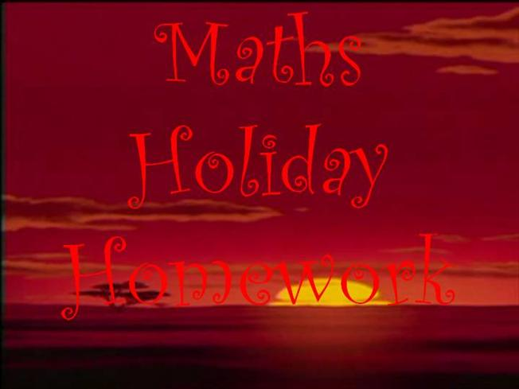
- Roll no. 1-11
# Visit to a bank,understand the working of different counters and design your own passbook using coloured sheet.
# Take the coloured printout of notes used before demonetization and changed notes after demonetization and laminate it.
- Visit to a bank,understand the working of different counters and design your own deposit slip using coloured sheet.
- Roll no. 12-23
# Take the coloured printout of notes introduced after the Revolt of 1857 with the head of King George VI and laminate it and find out the value of it. # Visit to a bank,understand the working of different counters and design your own withdrawl slip using coloured sheet.
- Roll no. 24-36
#Take the coloured printout of notes issued in 1812-issued by Bank of Bengal and laminate it and find out the value of it.
#Visit to a bank,understand the working of different counters and design your own chequebook using coloured sheet.
- Roll no. 1-36
# Visit to your grandparents and collect the currencies used in their times -5p coins,10 p coins,50 p coins,etc. and make a tracing of those coins with their values in an A3 size sheet.
- Roll no. 1-18:-
# Make a 3D model of goats,buffaloes,cows, using thermocol ,hard board,googly eyes to show the barter system in India.
- Roll no. 19-36:-
# Visit to National Museum at Janpath and find the story behind the emergence of coins, make a scrap book with colourful pictures taken from the museum with their details.
- Make a 3D model of e-payment apps using thermocol and coloured sheets like –
# Paytm (Roll no. 1-5)
# BHIM (Roll no. 6-10)
# Airtel Money (Roll no. 11-15)
# Tez (Roll no. 16-20)
# PhonePe(Roll no. 21-25)
# SBI Pay(Roll no. 26-30)
# ICICI Pockets(Roll no. 31-36)

- Make a 3D model of the logos of 14 nationalised banks in the year 1969 using thermocol and coloured sheets :-
Allahabad Bank, Bank of Baroda,Bank of India (Roll no. 1-7)
Roll no. 12-23:-Bank of Maharashtra,Canara Bank,Central Bank of India (Roll no. 8-14)
Dena Bank,Indian Bank,Punjab & Sind Bank (Roll no. 15-21)
Syndicate Bank,Indian Overseas Bank,UCO Bank (Roll no. 22-28)
Punjab National Bank,United Bank of India (Roll no. 29-36)
- Roll no. 1-9:-Make a 3D model of punch marked coins used in the 6th century BC called Puranas,Karshapanas or Pana issued by Mahajanapada like-Gandhara,Kuntala,Kuru,Panchala,etc. using thermocol and silver sheets.
for details visit to the link:- https://www.thebetterindia.com/61190/history-indian-rupee/
Present all the facts (atleast five facts) related to the above coins in an A3 size sheet.
- Roll no. 10-18:-Make a 3D model of punch marked coins issued by Mauryans called Rupyarupa(silver coins),Swarnarupa(gold coins),Tamararupa (copper coins),Sisarupa (lead coins)using thermocol and relevant coloured sheets.You may also paste the coloured printouts of these coins on a thermocol.
for details visit to the link:- https://www.thebetterindia.com/61190/history-indian-rupee/
Present all the facts (atleast five facts) related to the above coins in an A3 size sheet.

- Roll no. 19-27:-Make a 3D model of gold coins issued by Guptas using thermocol and golden sheets.You may also paste the coloured printouts of these coins on a thermocol.
for details visit to the link:- https://www.thebetterindia.com/61190/history-indian-rupee/
Present all the facts (atleast five facts) related to the above coins in an A3 size sheet.
- Roll no. 28-36:-Make a 3D model of coins issued by Sher Shah Suri called rupiya using thermocol and silver sheets. You may also paste the coloured printouts of these coins on a thermocol.
for details visit to the link:- https://www.thebetterindia.com/61190/history-indian-rupee/
Present all the facts (atleast five facts) related to the above coins in an A3 size sheet.

