CLASS I
SUMMER HOLIDAY HOMEWORK
(2018-19)
As the holidays have begun,
it’s time for us to have some fun. It is time to see amazing kids’ movies and help our mama in making goodies. We will make new friends and spend time with them. We got a big break from school,to enjoy the vacation and stay cool. We are free to do anything we like, playing, reading or riding our bike. We will sleep on time,and rise with the bright sun. As the holidays have begun,
It’s time for us to have some fun.

Looking forward to meet to you all in July……….

Happy Holidays!!!!!!!

Have a great
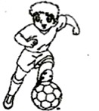
Dear Parents
Kids look forward to the summer vacation all year long. They look forward to having loads of fun and family time. With summer vacation right around the corner, its time to generate certain ideas to help children have a memorable vacation.
Growing your children’s talent
Help your children learn a sport or join talent class this summer. While learning new skill/ sport, children stay active and attentive.
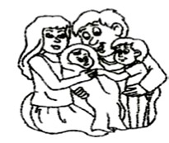
Creating a family bond
Along with varied activities, kids enjoy meeting people. Summer vacation is the best time to visit other members of the family who do not live in town. Kids really love the presence of Grandparents, aunts and uncles in their lives.
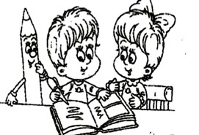
Inculcating Reading Skills: Get your children exposed to the fascinating world of fictitious characters through interesting story books. However, throw in some non-fiction reading as an added advantage.
Cyber Fun: Few suggested internet sites to visit
www.pitara.com, www.funbrain.com, www.magickeys.com (reading books), www.nationalgeographic.com
Involving In Household Chores
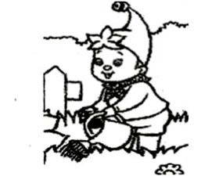
Assign your children a few tasks which they can easily accomplish like filling water bottles, keeping them in the refrigerator, watering the plants, cleaning dishes, folding washed clothes etc. This is how you can get your young ones get into the habit of helping out around the house. You will set a pattern that will benefit them when they grow up.Splash in water: Have fun while washing your own handkerchiefs, underpants and socks.
Note: A happy and healthy family time is the best way of imparting the much needed life skills to our children. We all wish to see them grow up as responsible and caring individuals who understand the value of time.
Celebrate your family and have a wonderful time together!
English

1). HAPPY READING !! – Read these stories :

* Snowhite and the seven dwarfs
* Sleeping Beauty
* Monkey and the capseller
* Cinderella

* Little Red Riding hood

- Pick out five new words from any of the two stories that you have read.

- a) Write down the words with their meanings on an A4 sheet.
b) Learn and narrate any two stories in the class using props (face
masks, hand puppets, flash cards)

2). English handwriting every week from the story books in a four line thin notebook.

3) VOCABULARY HANGING- (DESCRIBING WORDS)

Cut a big circle on an A-3 size sheet. Write a big word on it eg TREE and illustrate it. Now make as many DESCRIBING words as you can from the word- LEAFY, GREENY, SHADY etc and write each word on small circles or decorative cut outs of any shape from another A-4 sizesheet. Attach these cut outs to the big circle using satin ribbons .You can use your creativity to make the vocabulary hanging attractive.

MATHS
- Write number names (41-60) in the notebook.
- Make a necklace – using string and macaroni to show skip count of 2 and 5.
- Revise and complete chapter 1& 2.

SCIEnCE
- Have a close look at your surroundings while you are in the park. Observe how beautiful the flowers and plants are, how people are having fun and all the activities that you do to make your day a memorable one. On an A-3 size sheet, using materials such as dried leaves, match sticks, pencil shavings, cotton etc create a scene of the park you visited.
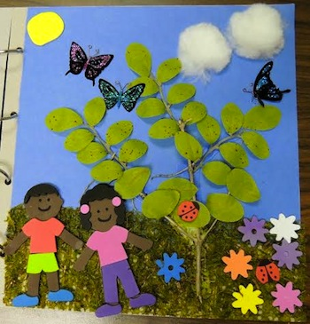
- Travelogues : Prepare a booklet/scrapbook using coloured paper about the place you visited during the holidays.
1. Name of the place you visited.
2. Where is that place?
3. How did you travel?
4. Who all went with you?
5. What did you see there?
6. Paste pictures and photographs

- Make a bird bath. Look for a flat container and place it on the balcony slab or outside your home. Put some pebbles in it. Pour some fresh water in it every day for the birds, squirrels etc to drink water from. Click pictures of your activity and paste it on a coloured A4 sheet..Don’t forget to include yourself in the picture. Write few lines on what you observed.
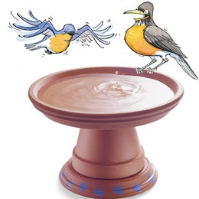

fganh
iz”u 1- Loj vkSj O;atu dk vH;kl fyf[kr #i ls ,d fnu NksM- dj djssA

iz”u 2- vius ifjokj dk fp= fpidk, vkSj vius ifjokj ij ikWp okD; ;kn fdft, A NfV;ks ds ckn mldh eqY;akfdr xfrfo/kh gksxh A

iz”u 3- fn, x, fo’k; es ls fdUgh nks fo’k;ks ij dfork daBLFk dhft, A
esjk fiz; f[kykSuk ] esjk fiz; [ksy ] ekW ] isM-

iz”u 4 “kCn vark{kjh “kCnksa dh jsyxkMh cuk, A

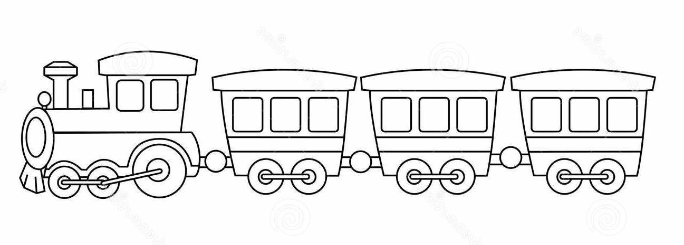

vFok

v] vk ]b ] bZ ]m ]m ek=kvksa ds fp= ,df=r djds dksykt cuk, A

CLASS I
PROJECT WORK (2018-19)

The potential to improve the learning, reading and experiential processes through play and toys is simply great. This was the idea behind, choosing this topic for our Annual Exhibition.
‘ANCIENT TO FUTURISTIC TOYS’ - A journey from civilization to digitalization. Let’s explore, research ideas and innovations.

Roll No : (1-4) - Dolls of India – Prepare 2 dolls of India using cloth/wood/wool/newspaper. Refer to the link given below :https://www.youtube.com/watch?v=zJ1KhcAavI8
Roll No :(5 -7)– Bhag Chal (Tiger and Goat) / Bhatukli (Kitchen set)/ Pachisi (ancient ludo) Prepare this ancient game using clay/ wood/ thermocol/ paint/ metal.Take the reference of the picture given below:
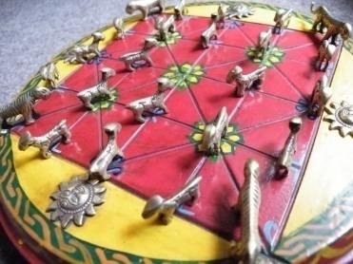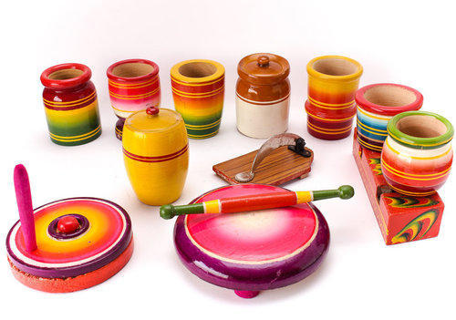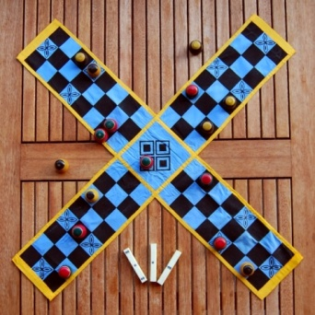

Roll No : (8-9) – Chauka Bara/ Pallanguli/ Chaduranga(ancient chess) – Prepare this ancient game using clay/cloth /wood/ thermocol/ cardboard/ paint. Take the reference of the pictures given below 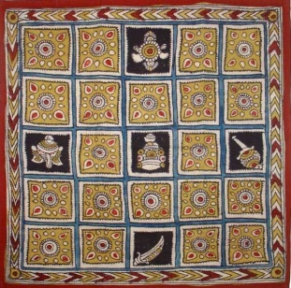 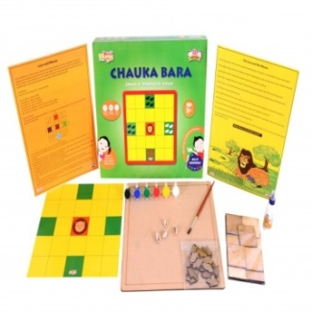 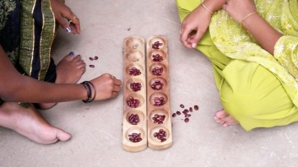 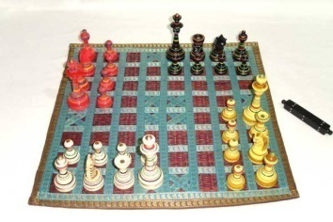

Roll No : (10-14) – Indian Puppets(Variation) – Prepare any 2 puppets using cloth /wood/ paint. Take the reference of the pictures given below:

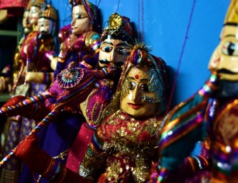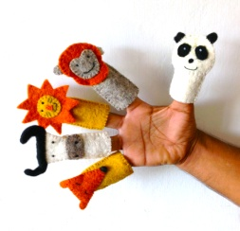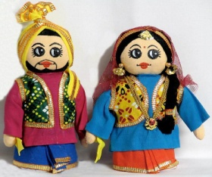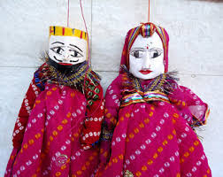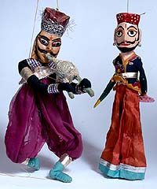

Roll No : (15-17) – Toys in Indus Valley and Harappa Civilization – Prepare 3 toys using clay. Take the reference of the pictures given below:

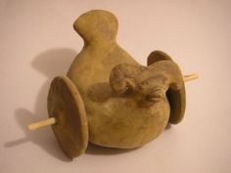
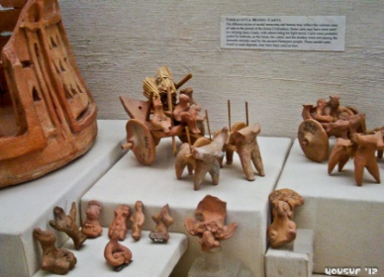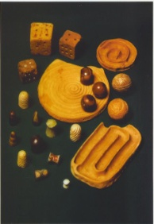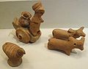

Roll No : (18-20) – Toys in Kondapalli – Prepare 2 toys using paper/wood/ clay/jute/thermocol/paint/ cloth. Take the reference of the pictures given below:
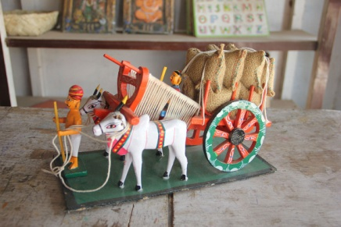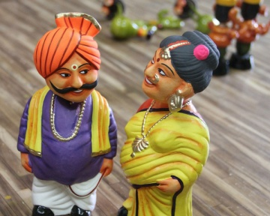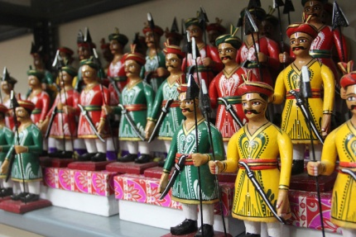

Roll No : (21-23) – Puzzles – Prepare 2 puzzles using paper/wood/cardboard/paint. Take the reference of the pictures given below:
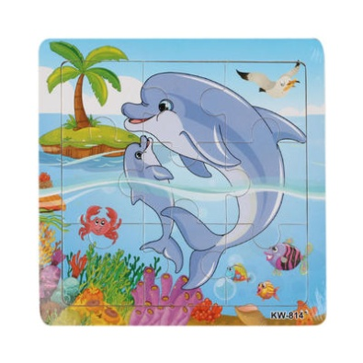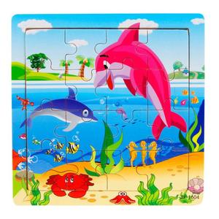
Roll No : (24-28) – Futuristic toys – Prepare 2 futuristic toys using plastic/wood/ jute/cardboard/paint/ cloth/thermocol. Take the reference of the pictures given below:
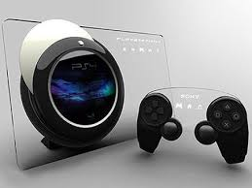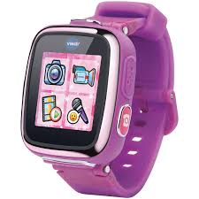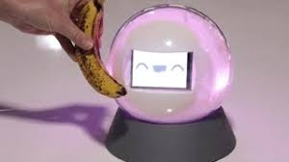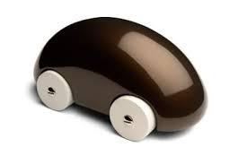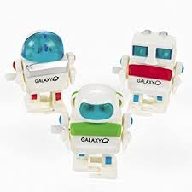

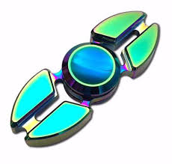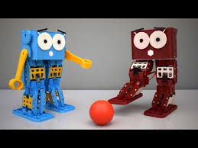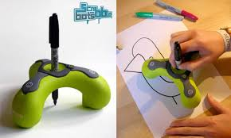

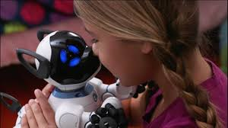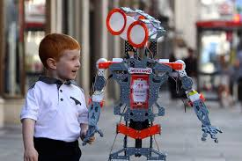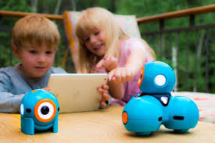

Roll No : (29-32) – Creative toys – Prepare 2 creative toys using plastic/wood/ quil/foam/ cardboard/paint/ cloth such as dominoes, scrabble, quilling toys.Take the reference of the pictures given below: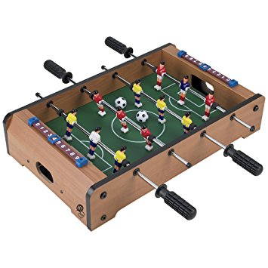 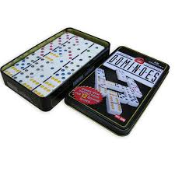 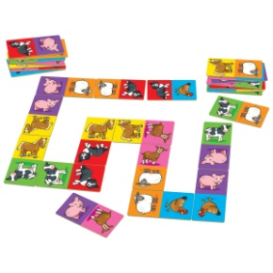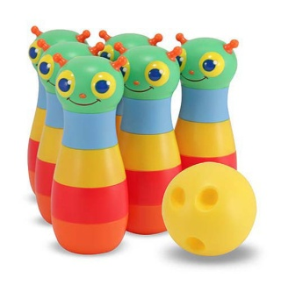 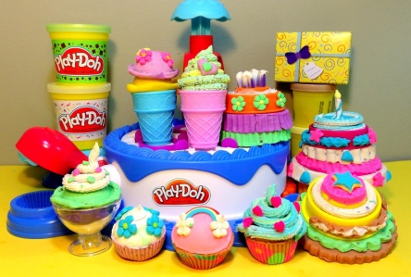 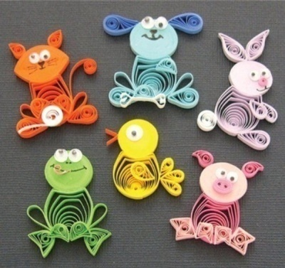

Roll No : (33-35) – Digital toys – Prepare 2 digital toys using plastic/wood/cardboard/paint such as drone, Interactive Digital stamps, Mobi Go etc. Take the reference of the pictures given below:

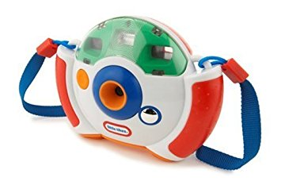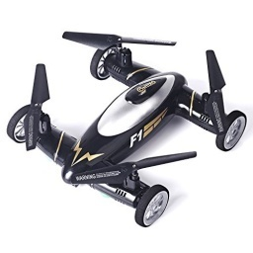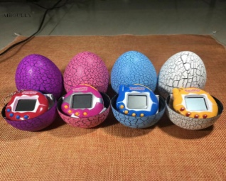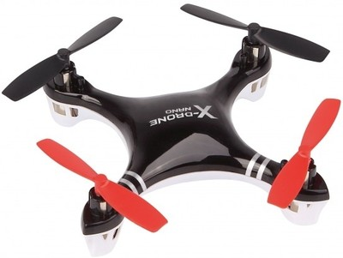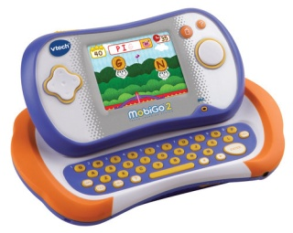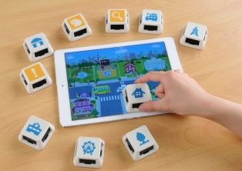

- Children are suppose to prepare A3 size poster of the toys they are making- mention toy’s name, picture, description, important features on the poster and decorate it nicely.

- Toys should be bright, colorful and creative as it will displayed in our Annual Exhibition. The size needs to be similar to the original toy.These are just reference images, you are requested to do more related research work if required.

Thank you for your diligent efforts !!

